SPED 860 Assignment 8

Use the readings, presentations, discussion in this module and your own experiences to complete the graphic organizer below.
Criteria | Ratings
Student Information | Provide a brief overview of the student’s interests, strengths and needs in relation to this SM program.
1- 2 paragraphs | Nevah Kelley is a 6-year-old 1st grade student diagnosed with ASD and meeting autism eligibility under IDEA. Nevah is currently placed in a self-contained classroom with three other students with autism and receives instruction from her teacher and a teacher’s aide. Her achievement testing shows that she is not far behind same aged peers in most academic areas. Her teacher and parents report that she enjoys being at school, likes to help out in the classroom, and likes to play with different toys like Lego, Care Bears, and the iPad. She avoids interacting with peers and struggles to interact appropriately. Nevah plays with some toys with their intended purpose but does not engage in play with her peers and has trouble sharing toys with other students. Nevah will take toys she wants from other students without asking. She also gets upset if another student has a toy she wants and she cannot have access to it. Nevah has limited verbal communication and primarily uses her AAC device to communicate with parents, teachers, and peers. Nevah also has difficulties with transition. She often throws tantrums when transitioning between activities within the classroom or other places in the school. This self-management program will address Nevah’s transitioning skills.
Social Relevancy | Explain the social validity of the SM program - how this program is relevant to this student in this setting at this point in time.
1-2 sentences | Transitions occur many times within Nevah’s day whether it is between activities within the classroom or to other places in the school. Teaching Nevah to transition appropriately and independently will increase her independence.
Reinforcers | Identify appropriate function based reinforcers.
1-2 sentences | The function of Nevah’s tantrums seems to be access to a desired item. She does not want to leave a preferred item or activity. By transitioning appropriately, Nevah will earn access to the iPad one of her preferred items.
Case Study Evidence | Refer to evidence from the case studies.
1-2 sentences | Observations of Nevah in the classroom as well as teacher reports show Nevah’s difficulty with transitions. Observations, parent and teacher reports indicate Nevah enjoys spending time on the iPad.
Behavior Operationally Defined | Target Behavior operationally defined in such a way that data collection from any observer can likely be consistently recorded
1-3 sentences | A tantrum is any occurrence of lying on the floor crying (any vocalizations accompanied by facial contraction with or without tears) and screaming (vocalizations above normal conversational volume) for any period of time.  Nevah will transition independently without tantrum behaviors by following a visual schedule for 100% of opportunities for 4 out of 5 days.
Data Collection | Identify & describe the data collection tools
1-3 sentences | Data collection will be done by recording a + or – on a data sheet for each opportunity Nevah has to transition. A + indicates she transitions correctly and a – indicates she transitions incorrectly.
Data Collection Visual | Provide a visual of the data collection method/materials.
Screenshot or insert picture from class, google or other sources | This data sheet will look something like this:  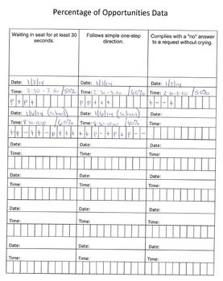
Self-Monitoring Tool | Describe the self-monitoring tool/device.
1-2 sentences | Nevah will have a visual schedule that shows her activities for the day. When she completes an activity and transitions correctly to the next one, she will place a check mark next to the picture of the activity she has completed.
Self-Monitoring Visual | Provide a visual of the SM tools and/or cueing devices.
Screenshot or insert picture from class, google or other sources | Here visual support will look something like this:  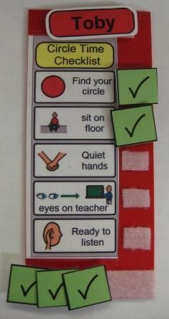
Instructional Strategy | Describe how you will teach the student to demonstrate correct behavior.
1-2 sentences | In order to teach Nevah how to use this transition prompt and the expectations for transition we will use modeling and prompting. A teacher will provide a model for Nevah to imitate and we will use most to least prompting to teach the appropriate behavior.
Reinforcement | Describe how the student will gain access to reinforcement when criterion is reached.
1-2 sentences | When Nevah reaches criteria, she will get access to the iPad. At first, she will only have to transition correctly close to her baseline percentage in order to access reinforcement. As she performs better, we will increase criterion to the desired rate.
Progress Monitoring | Describe how you will monitor student progress.
1-2 sentences | During 20% of all session we will monitor Nevah to make sure she is performing the behavior correctly and monitoring her behavior correctly.
Next Steps | Describe how you will make adjustments to the plan as needed and next steps.
1-2 sentences | If Nevah is showing progress we will continue to increase criterion. If she is not showing progress we will go back, make sure that the behavior is defined, that the reinforcement is appropriate, that she is using the self-recording system accurately and that the self-management is used with fidelity.
Course Materials | Refer to course materials.
1-2 sentences | The AFIRM module presents helpful information on implementing self-management strategies that includes progress monitoring and next steps.  AFIRM Team. (2016). Self-management. Chapel Hill, NC: National Professional Development Center on Autism Spectrum Disorder, FPG Child Development Center, University of North Carolina. Retrieved from http://afirm.fpg.unc.edu/self-management

