**CONFIDENTIAL**

**FUNCTIONAL BEHAVIOR ASSESSMENT REPORT**

*This Functional Behavior Assessment was completed to help determine maintaining variables for specific target behaviors. The FBA will assist with the development of a more specific plan to help improve behavior and foster success at school.*

Student: Jane Smith

Date of Birth: 10/19/2006

Age: 13

Date of Evaluation: 11/20/2019; 11/21/2019; 12/5/2019; 12/10/2019; 1/13/2020; 1/16/2020

Date of Report: 1/29/2020

Evaluator: Zack Cartmel

**REASON FOR REFERAL**

Jane’s parents requested an FBA to determine the function of her behaviors at school.

The FBA gathers information to determine the cause/function of the target behavior(s). This information is used in the development of the BIP and goals. The process involves observation and documentation of the target behaviors.

**SOURCES OF DATA**

In Class Observations

Data Collection

Motivation Assessment Scale (MAS)

Questions About Behavioral Function (QABF)

Information Provided by Teacher and Other Service Providers

Informal Interview with Teacher/Staff

Information Provided by Parent/Family

Review of Previous Assessments/Records

**TARGET BEHAVIORS**

Physical aggression – any instance of scratching (digging the fingernails into another person’s skin and/or moving them across another person’s skin), kicking (making contact another person’s body using a foot from a distance of six inches or more), or hitting (making contact any part of another person’s body with an open or close hand from a distance of six inches or more)

Crying – any occurrence of vocalization (sounds or words) accompanied by facial contraction with or without tears for any period of time

Below is a graph of data on physical aggression collected by Jane’s teacher, Ms. Miller.

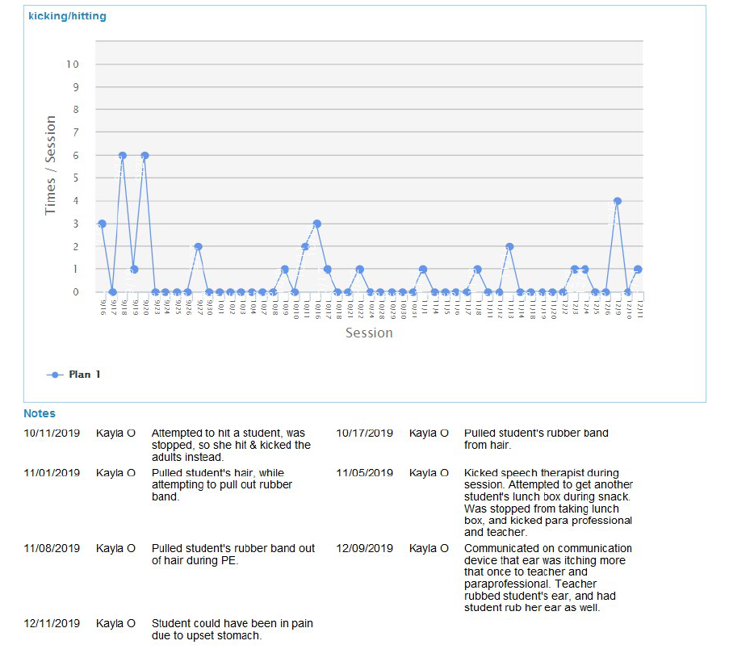

**PARENT INFORMATION**

A parent questionnaire was sent home and filled out by Mr. and Mrs. Smith, Jane’s dad and mom. They indicate that Jane works hard to stay regulated and that she has a love and skill for music. She also likes plastic bags and videos. Her parents report that Jane is very healthy and takes no medication except for melatonin at night. She has no significant medical history outside of delayed speech and bed wetting after age 8. Jane has a diagnosis of autism. She receives no outside counseling or other supports. They describe the home environment as peaceful and controlled. They say Jane has a low tolerance for other kids who may not be in control.

Jane’s parents indicate that Jane rarely engages in physical aggression but it usually takes the form of scratching. They also state that she has eloped in the past, but no longer engages in this behavior at home. They report that she runs away when she does not feel safe, and that she will also run to things that she wants.

Things that typically happen before the behavior are a less structured setting, provocation by peers, sensory overload, Jane may be emotionally upset or anxious, or in pain including symptoms of her cycle. Corrective feedback, a verbal reprimand, removal of privileges or an activity, or a cool off time typically follows the occurrence of problem behavior.

Mr. and Mrs. Smith report that firm boundaries are effective. They keep an eye on Jane at all times and hold her hand to make her feel safe and to keep her from running.

Mrs. Smith was also contacted via phone on January 14, 2020 to discuss effective strategies at home, Jane’s history, and additional considerations for the BIP and for the FBA. Mrs. Smith suggested modeling for Jane to indicate her stomach is hurting using her communication device. Jane’s hand biting behavior was also discussed as a self-regulation behavior that does not need to be intervene on.

**SCHOOL INFORMATION**

Ms. Miller, Jane’s teacher, and Ms. Jones, one of the classroom paraprofessionals, both filled out a questionnaire in regard to Jane’s problem behavior at school. Both staff members describe physical aggression as their primary concern. At school, Jane’s aggression takes the form of scratching, kicking, hitting, and hairpulling. Ms. Miller and Ms. Jones report that giving Jane space to cool off and redirecting her back to her chair is a strategy the class currently uses as well as reminding her what she is working for.

Ms. Miller reports that problem behavior typically occurs during work, when Jane is provoked by peers, when Jane is experiencing sensory overload, when a peer is reinforced (primarily with attention), during large group or whole class activities, when she is emotionally upset or anxious, and when she is on her period. Ms. Jones indicates that problem behavior typically occurs during work, when Jane is experiencing sensory overload, when a peer is reinforced, while waiting, and during large group or whole class activities. After the problem behavior occurs, the staff says that Jane has privileges or activities removed, is redirected to her task, the problem behavior is ignored, she has time to cool off and/or the room is cleared of people. Effective reinforcers include tangible items (plastic bag, iPad), a token system, verbal praise, and earned activities/privileges. Effective consequences for behavior have been to ignore the behavior, give time to cool off, removal of a reinforcer, redirection, and removing students who are disruptive. Ms. Miller also reports that there is an increase in physical aggression consistent with Jane’s cycle.

Jane was observed in the classroom on November 20 and 21, 2019, on December 5 and 10 2019, and on January 13 and 16, 2020, for two hours on each occasion. Jane worked independently with minimal redirection following an activity schedule. She worked for markers, for a plastic bag, and for the opportunity to cut paper with scissors on different opportunities for completing the activities. She worked with the speech language pathologist assistant and waited for her turn during the group session. In PE, she worked with the adaptive PE teacher and earned tokens for a break. She particularly seemed to enjoy bouncing the basketball. During PE on December 5, Jane passed the basketball back and forth with her PE partner, and joined in a game of jump rope with another group of peers. At lunch, Jane sat appropriately and ate her food. When she required assistance, she used her communication device to request help and vocalized “help”. On January 16, Jane completed the warm-up in PE and played catch with a basketball. During this she threw the basketball away and made attempts to scratch and kick. She was able to calm down and walked back to the classroom with the rest of the class.

**RESULTS and RECOMMENDATIONS**

The Motivation Assessment Scale (MAS) and the Questions About Behavioral Function (QABF) were completed by Ms. Miller to help determine the function of the problem behaviors physical aggression and crying. The MAS is a questionnaire to help identify situations where an individual is likely to behavior a specific way. The QABF is a questionnaire that asks about the likelihood for an individual to engage in a behavior in a specific situation. The MAS asks questions to evaluate the most likely situation from four possibilities: attention, escape, tangible, and sensory. Based on Ms. Miller’s responses to the questions, the MAS ranks the likelihood of functions from most to least likely to be: attention, escape, tangible, and sensory. The QABF uses five situations: attention, escape, non-social (sensory), physical, and tangible. Based on Ms. Miller’s responses to these questions, physical discomfort, attention, and escape are likely functions of the behaviors while tangible and non-social functions are unlikely.

Based on these assessments, observations, and input from staff and family, it is hypothesized that crying and physical aggression occur primarily when Jane is in physical pain or discomfort with a secondary function of gaining attention. Both at school and at home, if physical aggression does occur, it reportedly relates to physical discomfort or pain and could be a means of gaining the attention of staff members at school, particularly because she is in pain. It is also hypothesized that because of pain and discomfort, Jane may not tolerate aversive or uncomfortable stimuli (noise in the classroom, proximity of others, physical movement) as she typically does.

**RECOMMENDATIONS**

1. Update Jane’s Behavior Intervention Plan that supports the findings of the FBA. It is important the behaviors be addressed appropriately in order to see success. A BIP is not a quick fix; it is a detailed plan to address the target behaviors.
2. Provide visual supports to help facilitate communication.
3. Direct instruction of prosocial behaviors
   1. Instruction on using communication iPad to making requests
   2. Social stories to teach ways to gain attention, what to do when in pain, what to do when feeling sick
4. Set up opportunities to practice ways to get others attention (i.e. approaching staff and making requests using her communication iPad)
5. Provide Positive feedback and interactions throughout the day.

_____________________________

Zack Cartmel, Autism Specialist, RBT