1 pencil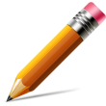

1 pen

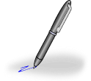

3 spoons

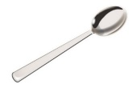

2 forks

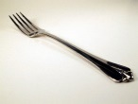

2 cups



3 books



2 sensory tubes

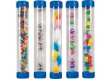

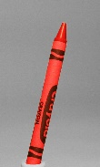4 crayons

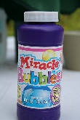2 bubbles

1 plate

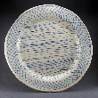

3 spoons



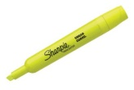4 highlighters



2 pencils



3 pens



2 cups



2 forks



1 stapler

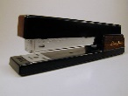

4 crayons

2 bubbles

1 plate



2 pencils



1 pen



4 highlighters



2 cups



2 forks



3 books



2 sensory tubes



4 crayons

2 bubbles

1 plate



1 pen



4 highlighters



3 spoons



2 cups



2 pencils



2 forks



2 sensory tubes



4 crayons

2 bubbles

1 plate



4 highlighters



2 pencils



1 pen



2 forks



2 cups



3 books



1 stapler



4 crayons

2 bubbles

1 plate

