PECS Project

Zack Cartmel

University of Kansas

PECS Project

For this project, I selected a student I work with who I believe lacks functional communication skills and may be a candidate for PECS.

# Bill

Bill is a 14-year-old, Latino 9th grader who meets eligibility requirements as a student with autism under IDEA as well as receiving a clinical diagnosis of autism spectrum disorder at the age of 3 from a local developmental pediatrician. Bill received ECI services upon receiving his diagnosis. He was enrolled in a Preschool Program for Children with Disabilities (PPCD), attended kindergarten in a self-contained classroom with other students with disabilities, and has been in the local public school district’s Reaching Independence through Structured Environment (RISE) program for students who require the most substantial levels of support since the 1st grade. This program involves low staff to student ratios (an average classroom has one teacher, two paraprofessionals, and 5 students) and focuses on developing communication and functional skills through direct instruction.

**Recent Assessment Results**

On the Wechsler Nonverbal Scale of Ability, Bill had a standard score of 42 indicating the low range of functioning. His parents and teachers reported a low range of functioning for his adaptive behavior. According to teacher reports, Bill’s skills in reading, writing, and math are below grade level.

Bill’s present levels of performance as reported by his teacher are as follows:

Bill can follow a first/then schedule as well as follow the sequence of a daily schedule. Bill can count several specified times using a number line for numbers 1 to 10. Bill can count backwards from 5 when counting down to be chased. Bill also recognizes numbers 1 to 10 when putting the dates up on the calendar. Bill can sequence pictures from his daily picture schedule with 80% accuracy. He is also able to name 11 pictures from his daily schedule. Bill shows interest in books and will look through them. He will follow along and echo reading. Bill attends to a story when it is read to the group. Bill can collect items from a list with words and pictures of up to 10 different types of items with different amounts of each item. Bill can write his own first and last name when given the instruction to write his name. He writes his name with proper capitalization. Bill can trace all letters. Bill is also good at imitating writing when given a model. Bill can write his phone number when instructed.

Currently, Bill has some one-word utterances to express his wants and needs. He asks for things like restroom, iPad, gummies, and Skittles. Bill sometimes leads his teachers to the things he wants or points to them from across the room. Bill has a hard time choosing rewards that he wants to work for and the teacher is often left unsure about what activity or item he wants. Bill occasionally throws items in the classroom.

**Parent Concerns**

Bill’s parents are concerned about his ability to communicate his wants and needs. At home, if he wants something, he takes it if he can get to it without asking. If he cannot access it, he points to or leads his parents to the item. Like at school, Bill asks for common preferred items with a one-word utterance. Bill occasionally throws items at home and sometimes hits his siblings when he cannot get what he wants.

**PECS Flow Chart**

The first question in the flow chart is, “Is the learner using functional communication?”. Bill sometimes has functional communication with his one-word utterances for common reinforcers or by leading people to items. Most of the time, Bill is unable to express his wants and needs in a functional way. In the classroom, his teacher is left guessing different items that he wants, which can lead to problem behavior from Bill when she guesses the wrong item. The parents experience a similar thing at home. Another question on the flow chart is, “Does the learner use multiple word utterances?” Bill is reported to only use one-word utterances across settings. A third question is “Does the learner have appropriate vocabulary size?” Bill is only able to request a few common reinforcers and does not have ways to communicate other wants and needs. Since the answer to these three questions is “No”, I believe Bill is a good candidate for PECS. Bill’s Communication Skills Checklist can be found in Appendix A.

# PECS Reinforcer Worksheet

The PECS Reinforcer Worksheet (Appendix B) was used to identify preferred items to use for Phase I of PECS instruction. The items that were used to complete to worksheet were: Skittles, chips, gummy bears, raisins, an iPad, orange Gatorade, markers, a book, and Hershey’s kisses. These items were selected from the Vocabulary Selection Worksheet (discussed below) and from observing the student during a “free access” situation. Bill pushed the book and Hershey’s kiss away when they were offered. He did not react to chips, raisins, or markers when those were offered. He reached for Skittles, gummy bears, the iPad, and the Gatorade when those were offered to him. When presented the four most preferred items, Skittles were selected most often, then the iPad, then gummy bears, and finally Gatorade. This is the order of the preferred items. The chips, raisins, and markers are neutral items, and the book and Hershey’s kiss were non-preferred.

**Vocabulary Selection Worksheet**

The Vocabulary Selection Worksheet (Appendix C) was completed to help identify reinforcers for Phase I of the PECS intervention. The worksheet was completed by me, Bill’s teacher of 2 years along with input from a reinforcer survey that Bill’s parents completed for me at the beginning of the school year. Things that Bill likes to eat are: Skittles, chips, gummy bears, Goldfish crackers, pizza, sour gummy worms, and raisins. Things that Bill likes to drink are: Coke, chocolate milk, lemonade, flavored water, Gatorade (all kinds), blue Powerade. Activities that Bill likes are: tag, playing catch, kicking a ball, spinning, watching the iPad, coloring, and sitting in a rocking chair in the classroom. Social games Bill likes are: chase, tickles, high fives, catch, and kicking a ball. Places Bill likes to visit are: the gym (at school and the local recreation center), the science museum, and the swimming pool. In his free time at school, Bill likes to watch the iPad, color, and sit in the rocking chair. Bill recognizes and enjoys being with his mom, his dad, his grandma, the staff in his self-contained classroom, and the PE coach at school. Bill does not like reading books, Hershey’s kisses, vegetables, writing, and typing on the computer.

**PECS Materials**

For Phase I of the PECS intervention, 1.75-inch by 1.75-inch picture cards were created for the iPad, Gatorade, Skittles, and gummy bears. These were laminated and Velcro was placed on the back. Since Skittles and the iPad were identified as the most preferred items, these were used for data collection in Phase I. Materials can be viewed in Appendix D.

**Results for Phase I**

Preparation for implementing Phase I of PECS for Bill began the week of October 28, 2019. Data collection began on October 31, 2019 upon the receipt of feedback from the professor. On October 31, we began using the Skittle picture for five trials, then switched to the iPad for three trials as Bill grew tired of Skittles. Over the course of the trials, the level of prompting decreased and the communicative partner was able to close their hand. Eight trials were completed for Phase I on this first day. On November 1, 2019, nine trials were completed. We started again with Skittles for the first 5 trials and switched to the iPad for four trials when Bill grew tired of Skittles. Bill independently exchanged the picture for the iPad on the last two trials on this day. He also required less prompting for exchanging the picture of the iPad than for the Skittles. On this day, only one step required full physical prompts, partial prompts were used when Bill needed prompting. On the following Monday, November 4, 2019, eleven trials were completed. We started with Skittle for eight trials and switched to the iPad for three trials when Bill grew tired of Skittles. On this day, Bill required no physical prompts only partial physical prompts. Bill had five independent exchanges, three for a Skittle and two for the iPad. On November 5, 2019, Bill showed a natural interest in the iPad so ten trials were conducted using his natural motivation. Bill exchanged the picture independently four times and required fewer prompts than previous days although he did require a full physical prompt for one trial. On November, 6, 2019, Bill only required prompting on three occasions. He responded independently in seven of ten trials. These trials occurred in the natural environment during snack time where Bill exchanged the pictures for Gatorade and Skittles. On November 7, 2019, due to the constraints of this course and the improved independent responses Bill shows, we moved on to Phase II of the PECS intervention. Data sheets for Phase I can be viewed in Appendix E.

**Results for Phase II**

Phase II data was collected on November 7, 2019 and November 8, 2019. Bill has previously learned to travel to a listener to make a request, so he made fast progress through Phase II. On November 7, Bill started with his communication book right next to him and traveled five feet to his communication partner. He required a small prompt on this first trial. By the end of the day, Bill was traveling four feet to his PECS book and ten feet to his partner, even when the partner had their back turned. Data was taken during free play and snack, using the iPad and the Gatorade pictures. When Bill did require prompting, only slight guiding prompts were used to direct him. On the next day, November 8, Bill picked up where he left off on the previous day. Data was collected during snack and a “staff party” where the staff did not focus on the student, but rather the preferred items to create opportunities for Bill to request the item. Different communication partners were used for different activities. Bill started the day traveling seven feet to his communication partner and worked his way up to ten feet again. He started four feet away from his PECS book and eventually traveled ten feet to the PECS book independently for the final two trials. Bill traveled to his book and to his communication partner for nine of ten trials on November 8. Only on the first trial of the day Bill required slight physical prompts to travel to his book and to his communication partner. Data sheets for Phase II can be viewed in Appendix F. Phase IIIA was started in the afternoon of November 8 due to Bill’s success at independently traveling a variety of distances to his PECS book and to a communication partner.

Phase II data collection continued the week of November 11, 2019. Bill’s ability to travel to his communication partner and to his communication book was assessed throughout his day by withholding required items to complete tasks. For example, Bill had to use PECS to request required parts of the craft the class was completing. Bill had to use PECS to request for more of his snack. He also had to request for missing pieces of his puzzle and for missing pieces to the Connect 4 game. Data from these sessions can be viewed in Appendix F. Through these sessions, Bill required few prompts and showed a strong ability to travel to his communication partner and book to get his needs met. He regularly traveled large distances to his book and to his partner to retrieve and exchange the PECS picture.

**Results for Phase III**

One session of data was collected for Phase III on November 8, 2019. Only Phase IIIA data was collected since the discrimination of pictures in the PECS book was just introduced on this day. The highly preferred picture for these trials was the Skittle picture. The distractor picture was a picture of a sock. Bill selected the Skittle seven times and the sock three times. Each time he selected sock he had a negative reaction to selecting the distractor item. For the last three trials, he selected Skittle reliably. The data sheet for this session can be viewed in Appendix G. We continued collected Phase IIIA data on November 11, 12, 13, and 14. On a few occasions, Bill selected the distractor picture and consistently showed a negative reaction when selecting the distractor. Bill showed improvement in discriminating between the highly preferred item and the distractor. On November 13 and 14, we collected data for Phase IIIB, since Bill showed the ability to select a highly preferred item over a distractor item. On November 18 and 19, additional data was collected on Phase IIIA to check that Bill continued to discriminate between highly preferred items and a distractor. Bill showed a continued ability to do so.

In Phase IIIB, on November 13 and 14, Bill struggled with the correspondence of the pictures to what he chose between two preferred items. Bill frequently took the item he did not exchange the picture of. More time is needed for Bill to work on discrimination between preferred items to ensure Bill is selecting the picture of the item he wants. Phase IIIB data collection continued November 18 through the 22. Bill showed a steady increase in his performance on discriminating between preferred items and selecting the corresponding item in the correspondence check. On November 22, Bill met mastery criteria for beginning Phase IV by reaching at least 90% correct on correspondence checks for three consecutive days. Phase IV data collection will begin at the next data collection opportunity. Bill also continued to show an ability to travel a variety of distances to his communication book and to a communication partner. Bill’s longitudinal progress can be viewed in Appendix H.

**Phase IV**

For Phase IV, we will use backwards chaining to teach Bill to use the “I want” picture and the sentence strip. The steps for teaching Phase IV are:

1. Get book
2. Remove “I want” icon from book
3. Put “I want” picture on the sentence strip
4. Remove reinforcer picture from book
5. Put reinforcer picture on sentence strip
6. Remove sentence strip
7. Give sentence strip to communicative partner

Since we are using backward chaining, we will teach Bill the last step, giving the sentence strip to the communicative partner, first. As with previous phases, only physical prompts will be used to teach these steps.

Phase IV will include teaching attributes of items and being able to use PECS to request specific types of items, for example, red Skittles rather than green Skittles. For teaching this skill, we will also use backward chaining. To start, we will determine what attribute is important to Bill. I predict that color will be important. He tends to like certain colors of Skittles and gummy bears than others. He also only likes orange Gatorade, so being able to request specifically orange Gatorade would be important. The steps for teaching attributes are:

1. Teach three-picture sentence construction
2. Discrimination between high-preference and low-preference attribute icons
3. Discriminating between icons representing two or more preferred examples of a preferred item
4. Increase the complexity of the attribute discrimination task
5. Introduce additional exemplars for this attribute

We will teach color first. For the first step we would teach Bill to construct a sentence with the “I want” picture, a color, and the preferred item. Then, we would teach Bill to discriminate between a preferred color and a low-preference color. Then, multiple highly preferred colors. Then, multiple preferred items that have differences in color. This way, Bill can request for specific colors and other attributes of items.

Data will be collected on what level of prompting Bill requires to put the picture of the item on the strip, put the “I want” picture on the strip, exchange the strip, “reading” the strip, and correspondence checks for the items requested. When working on attributes, we will also take data on level of prompting required for Bill to put the attribute on the sentence strip. An example of the data sheet can be viewed in Appendix J. We will know that Bill has mastered Phase IV when he is completing all the steps independently across 3 consecutive days. Bill will also have twenty or more pictures on the communication board and be communicating with a variety of partners.

Data collection for Phase IV began on December 2, following Thanksgiving Break from school. On the first day of data collection, we focused on Bill pointing to the pictures independently after exchanging the sentence strip. Since we are using backwards chaining to teach the steps of Phase IV, this is the last step in that sequence, so the first step to teach Bill to complete independently. On the first day, Bill was able to reliably point to the pictures on the strip for the last eight trials of the day. The next day, on December 3, Bill completed the pointing to pictures step in seventeen of twenty trials with only partial physical prompts needed in the other three trials and all steps independently in six of twenty trials. On December 4, Bill pointed to the pictures independently for fifteen of seventeen trials. He completed all the steps independently for seven of seventeen trials. On December 5, for all twenty trials Bill pointed to the pictures independently. He exchanged the strip independently for seventeen of twenty trials, mostly requiring only partial physical prompts. He completed all the steps independently for seven of twenty trials. On December 6, Bill exchanged the strip and pointed to pictures independently for all fourteen trials of the day. He also completed all the steps independently for ten of fourteen trials. These data sheets can be viewed in Appendix J. Data and training will need to continue to be collected, as Bill has not met mastery criteria for Phase IV.

**Phase V**

Phase V will begin when Bill reaches the mastery criteria for Phase V outlined above. Phase V involves Bill requesting a variety of items and being able to answer the question, “What do you want?”. This phase involves continuing verbal and tangible reinforcement of correct responses. A procedure called “delayed prompting” with progressive time delay is used during training of this phase. The steps for Phase V are:

1. Zero second delay
2. Increasing the delay interval
3. Switching between responsive requesting and spontaneous requesting

Delayed prompting is what occurs during steps 1 and 2 of this phase. In this procedure, a gestural prompt for Bill to select the I want card is given simultaneously with asking him, “What do you want?” Then, over time the gestural prompt is delayed for longer amounts of time for Bill to “beat” the prompt and respond independently. This allows Bill to respond to the question without making errors.

Data will be recorded on how long the gestural prompt is delayed, whether or not Bill answers the question (which he should do unless the prompt is ineffective), whether or not he beats the prompt, any time he makes a spontaneous request, and a correspondence check for symbol-object correspondence. Throughout this phase, Bill will continue to receive reinforcement for spontaneous requesting items. A data sheet for Phase V can be viewed in Appendix K.

**Report**

Bill was selected for this PECS project because he had no functional method of communication. Before the intervention, Bill primarily communicated through single word utterances or leading people to things that he wanted. Often, his needs were not being met through this communication method which led to Bill becoming upset. Reinforcers were identified to use to begin teaching the PECS to Bill.

In Phase I, Bill learned to exchange a picture with a communication partner to gain access to an item. Bill exchanged pictures for his most preferred items like the iPad, Skittles, gummy bears, and Gatorade.

In Phase II, Bill was taught to travel to his communication book and to a communication partner. Bill learned to travel up to 10 feet to his communication book and up to 10 feet to his communication partner to retrieve and exchange a picture for a desired item. Bill also learned to approach communication partners who were sitting, standing, facing him, or who were facing away from him. Bill learned to do this in a variety of context like during snack, during contrived “staff party” situations, during leisure time, during group activities, during crafts, etc. The communication partner responsibility rotated between staff members allowing Bill to learn to approach a variety of different partners.

In Phase IIIa, Bill learned to discriminate between an icon for a preferred item and a distractor icon to select it and exchange it for the desired item. This led into Phase IIIb where Bill learned to discriminate between multiple preferred items and distractors in his communication book. At first, Bill was learning to discriminate between just two preferred items, but Bill was able to discriminate between four preferred items and a distractor icon. In these phases, correspondence checks were performed to make sure Bill was exchanging the picture for the item that he wanted. Bill met mastery criteria for Phase IIIb and moved on to Phase IV.

In Phase IV, we began training Bill on sentence structure. Bill started to complete parts of the Phase IV training independently, but has not yet reached mastery criteria. We also have not yet started teaching Bill how to comment on attributes because he is not able to fluently communicate with proper sentence structure. We will continue working with Bill on sentence structure and attributes.

**Future Development**

As stated above, we will continue to work with Bill using PECS to develop communication skills. We will work on Bill being able to comment on attributes of desired items. This will allow Bill to communicate specific requests like a certain color, flavor, size, or amount of an item that he wants. Phase V of PECS will teach Bill to respond to the question, “What do you want?” This is a good way to start teaching Bill how to answer questions. Responding to this question is also naturally reinforced by providing the tangible that Bill responds with. Phase VI of PECS will teach Bill how to make spontaneous comments about his environment as well as answering questions like, “What do you see?” “What do you have?” “What do you hear?” and “What is it?” These skills will allow Bill to communicate with others about the world around him and respond to questions from communication partners. PECS will provide Bill with a communication system that allows him to comment on his environment, make specific requests, and get his needs met.

Additional skills that will be worked on include Bill requesting for assistance by exchanging a symbol for help, teaching Bill to be able to answer the question, “Do you want?” by exchanging a PECS symbol for yes or no, and teaching Bill to exchange a symbol for a break. Being able to request help is important for Bill to gain assistance rather than becoming upset or frustrated when he cannot accomplish a task on his own. The question, “Do you want?” commonly occurs during Bill’s day, particularly at lunch when going through the cafeteria line. Bill being able to answer this question allows him to communicate with more people and answer a question he hears frequently. Bill being able to request a break is useful for times that he gets frustrated with difficult tasks or tired of a boring task. This skill will also be useful in his future with vocational tasks and being able to request a break from work appropriately.

A further development that may be useful is for Bill to use an AAC device. If Bill continues to make progress with PECS this may be considered. Bill would have to be able to initiate as frequently with the device as with PECS. He would have to be able to access the same number of words with the device as with PECS. He would have to be able to continue to communicate with the same length of sentences. Finally, the device would need to be as understandable to a general audience as PECS. If these criteria are met, a move to an AAC device may be appropriate for Bill.

**PECS and Other Methods of Communicating**

PECS is an evidence-based intervention based on substantial research that supports its efficacy. On the other hand, facilitated communication and rapid prompting method are dangerous, pseudoscientific practices that rely on the hope of families to communicate with their children to continue existing in the field of educating individuals with disabilities. When comparing the components of both interventions it becomes clear what makes PECS effective and what makes facilitated communication and rapid prompting method illegitimate methods of communicating.

When using PECS, the student is taught how to independently initiate a request. Students can travel to a communication partner across a variety of distances and conditions. This occurs in Phase II and it is continually monitored throughout the PECS training process. On the other hand, facilitated communication and rapid prompting method rely on a facilitator to initiate the interaction. The facilitator is needed to help the student point to letters or to type out and communicate. If the facilitator is necessary how do we know if the student truly wants something? With PECS we can be certain that the student is the one initiating the communication.

PECS also emphasizes the fading of prompts. PECS often uses errorless teaching to teach students a new step in the PECS process. This involves prompting the skill and eventually fading the prompt so the student engages in the behavior independently. In facilitate communication and rapid prompting method, prompts are never faded. In fact, prompting is in the name of one of the strategies! The children never truly engage in the behavior on their own. They always require assistance from another person. PECS allows for independence while the other two methods do not.

Another important process of PECS is that it incorporates correspondence checks into the process. This means that checks are done to make sure that the picture that the student is exchanging is the item that they want. This shows that PECS is a communication method that we can confirm is accurately representing what the student wants. Facilitated communication and rapid prompting method do not involve correspondence checks. Facilitated communication has had several cases of devastating inaccuracy of communication. Reports of abuse have come through communication with a facilitator that were ultimately untrue, leaving devastation in their wake. Clearly, facilitated communication is dangerous and does not accurately express what a child wants to communicate.

These factors contribute to the legitimacy of PECS and the illegitimacy of methods like facilitated communication and rapid prompting method. PECS allows for students to communicate independently and get their needs met. Facilitated communication and rapid prompting method always require assistance and do not accurately communicate what the student wants to communicate, but are influenced by the facilitator.

Appendix A

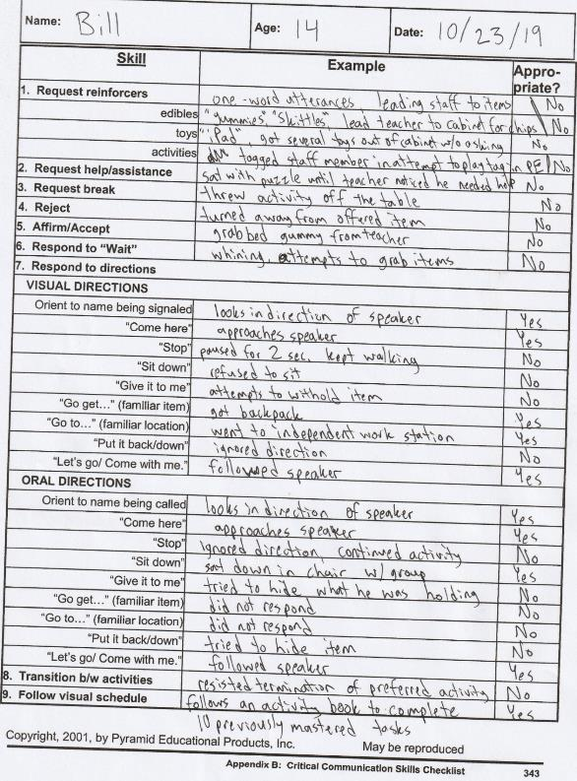Bill’s Communication Skills Checklist

Appendix B

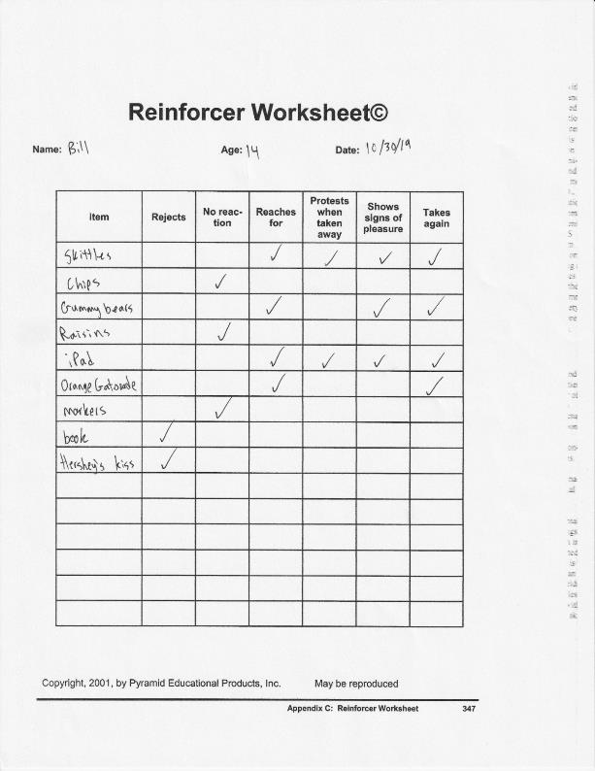Bill’s PECS Reinforcer Worksheet

Appendix C

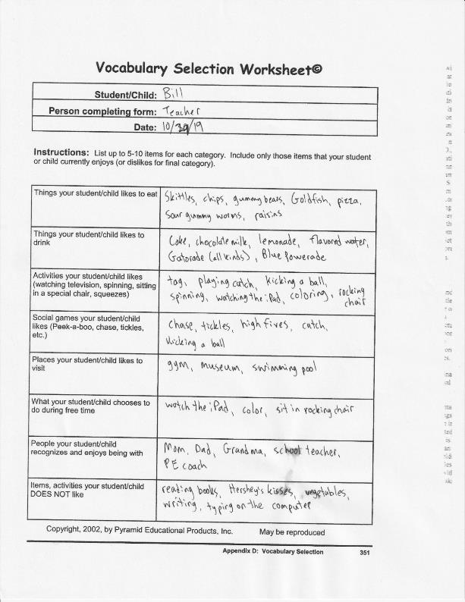Bill’s Vocabulary Selection Worksheet

Appendix D

Bill’s PECS Materials

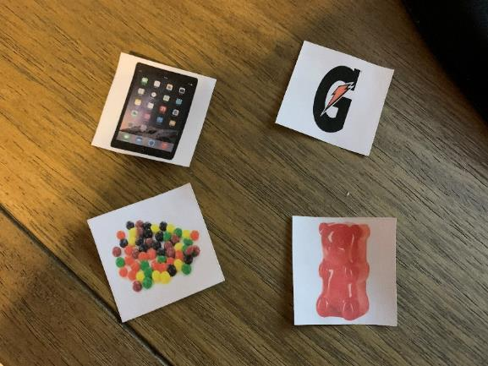

Appendix E

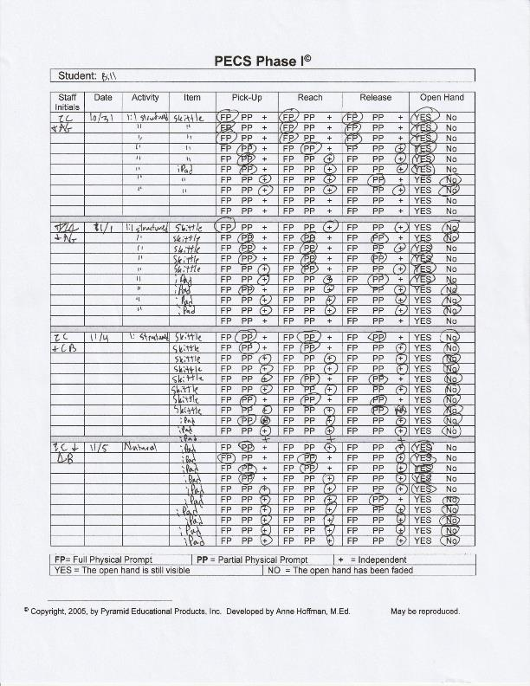Bill’s Phase I Data

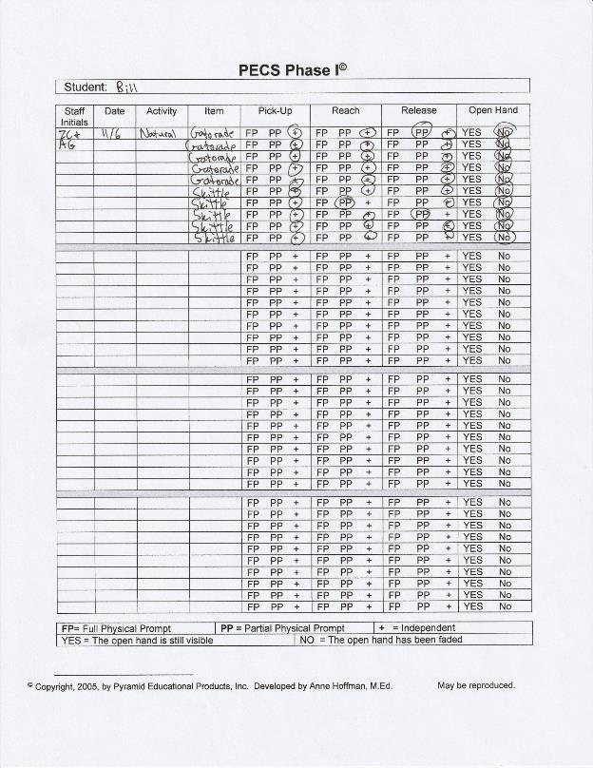

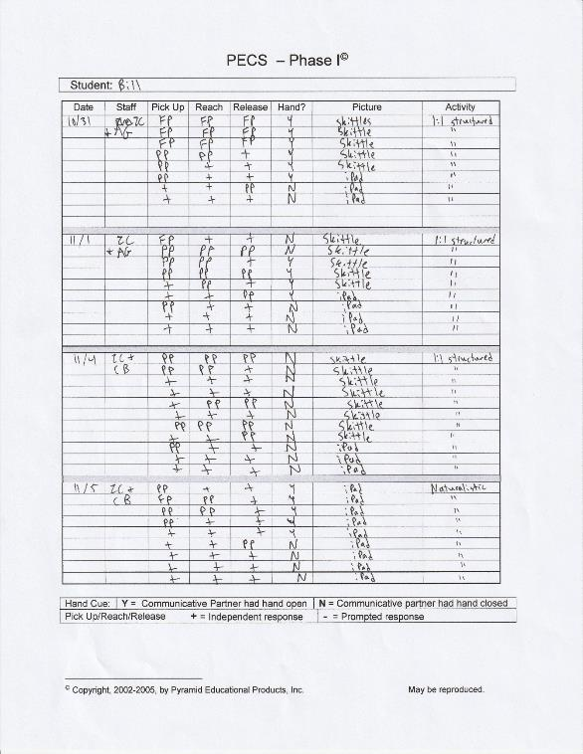

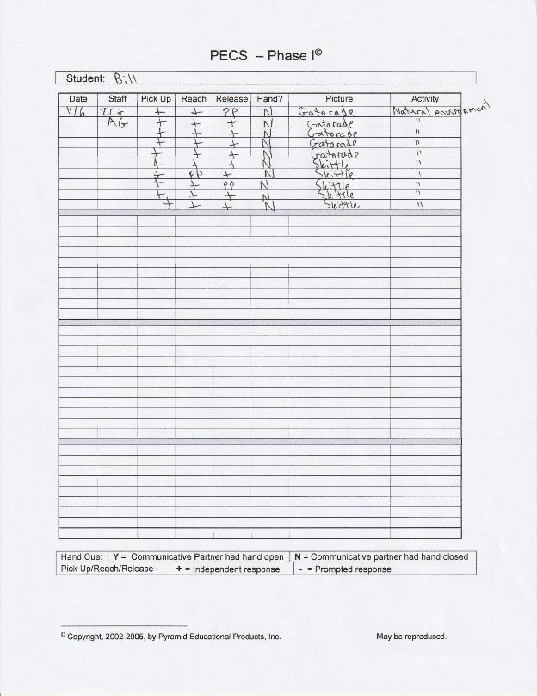

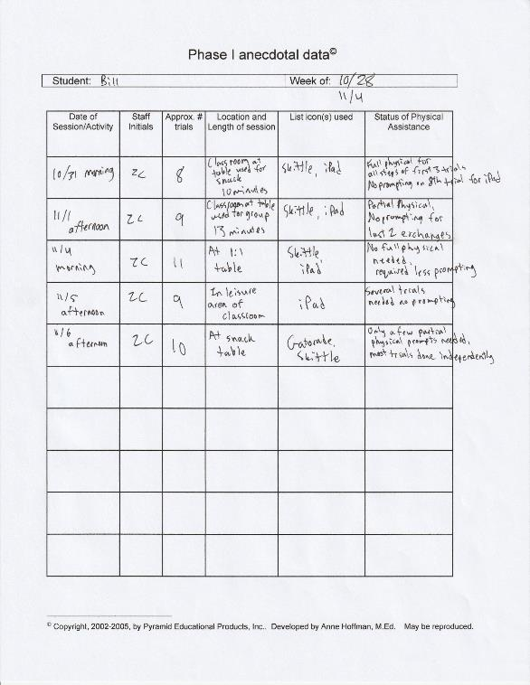

Appendix F

Bill’s Phase II Data

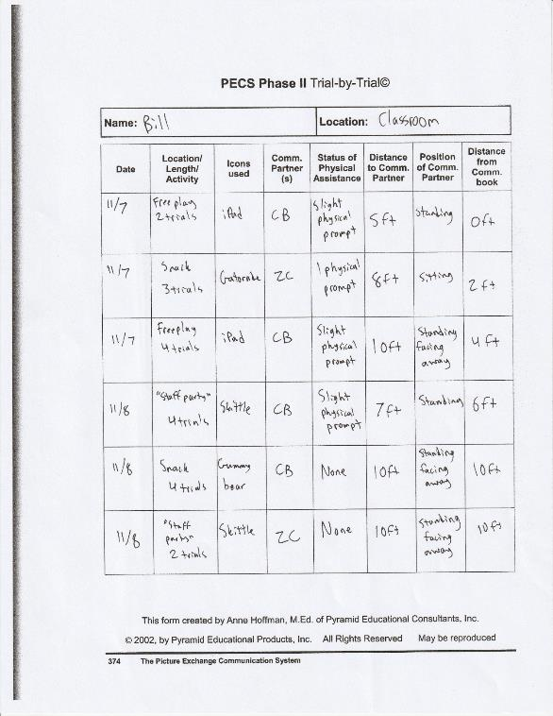

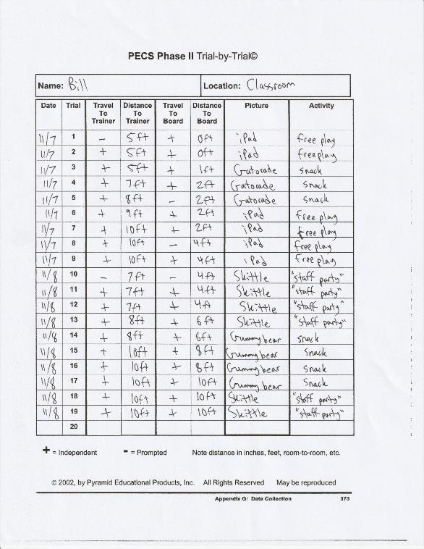

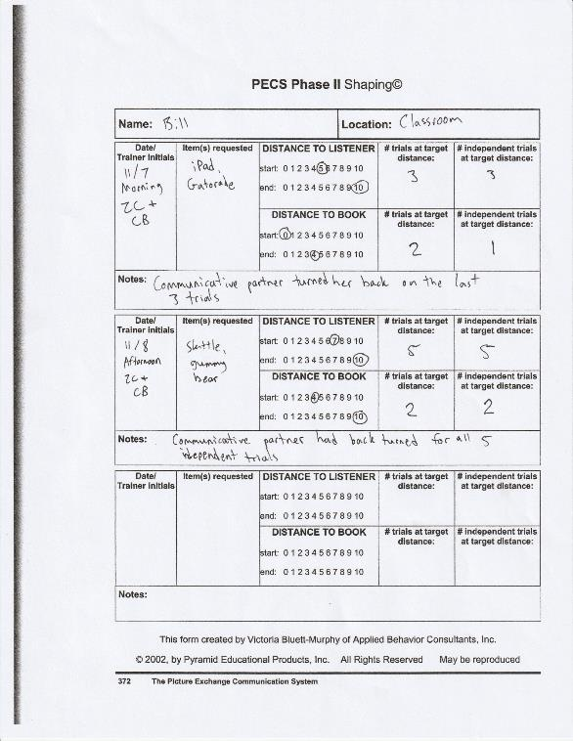

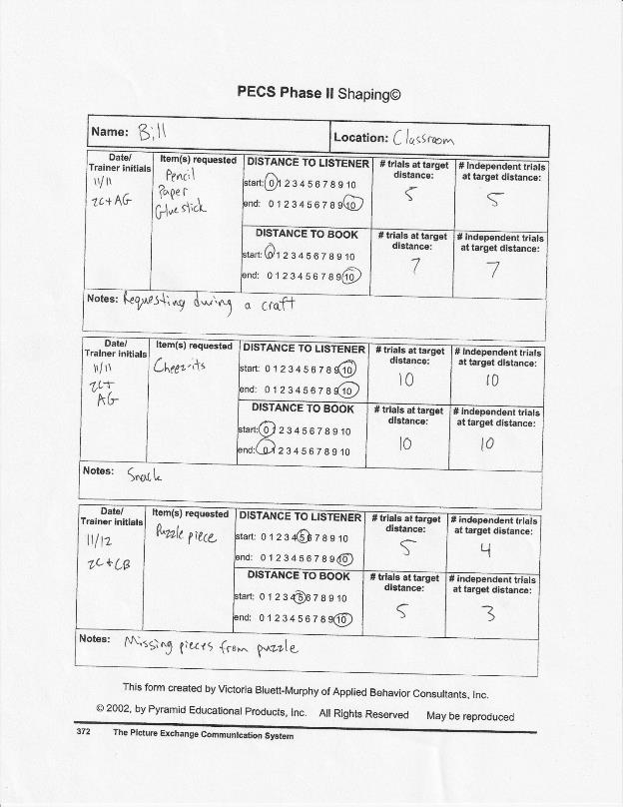

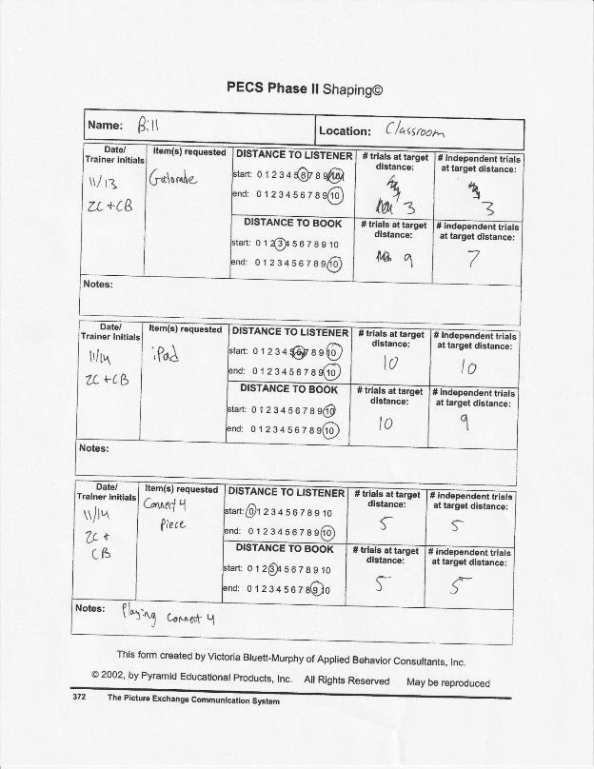

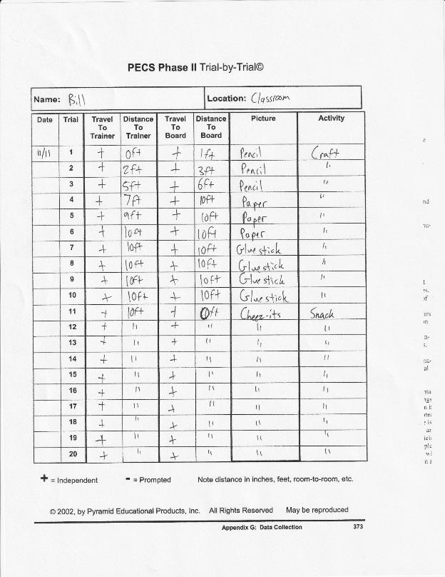

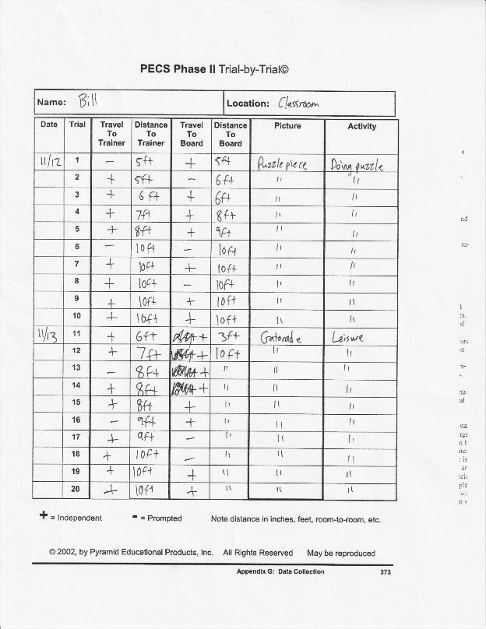

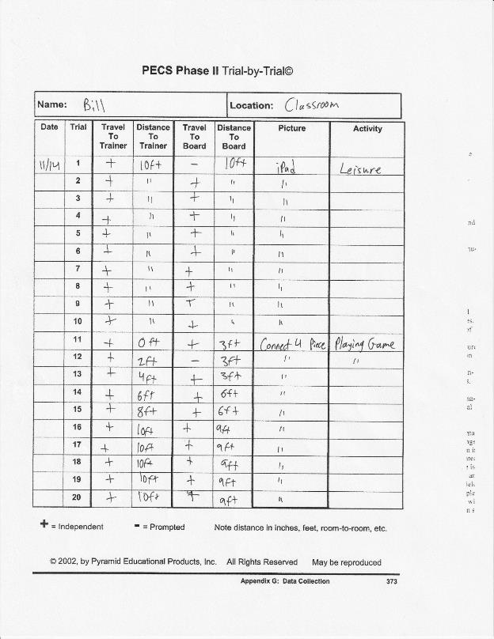

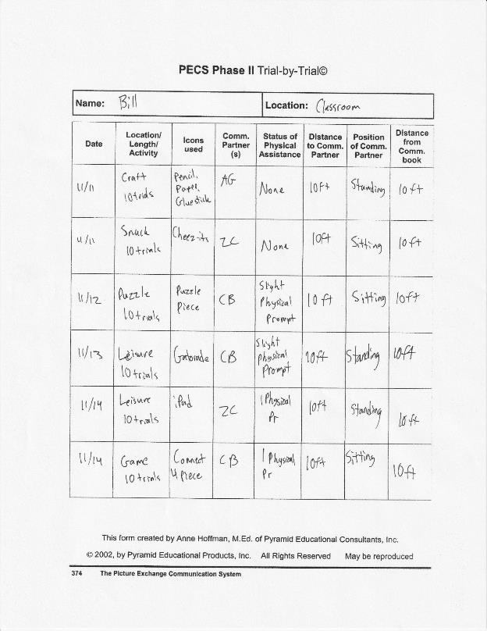

Appendix G

Bill’s Phase III Data

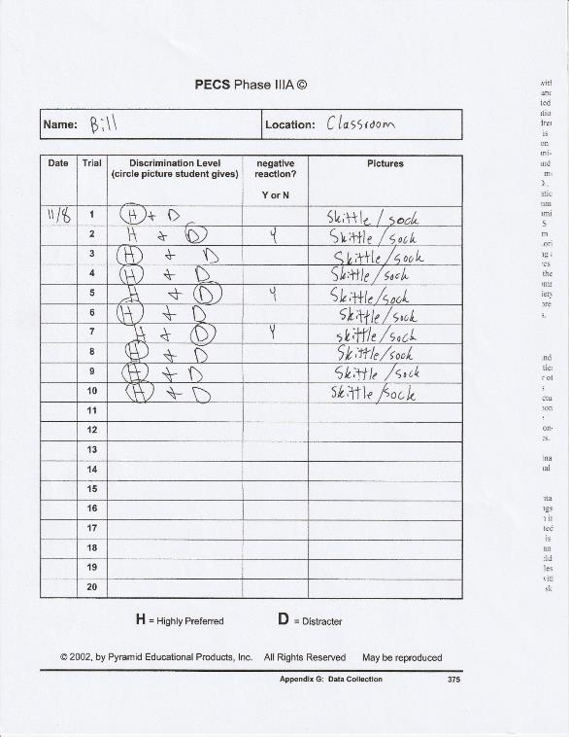

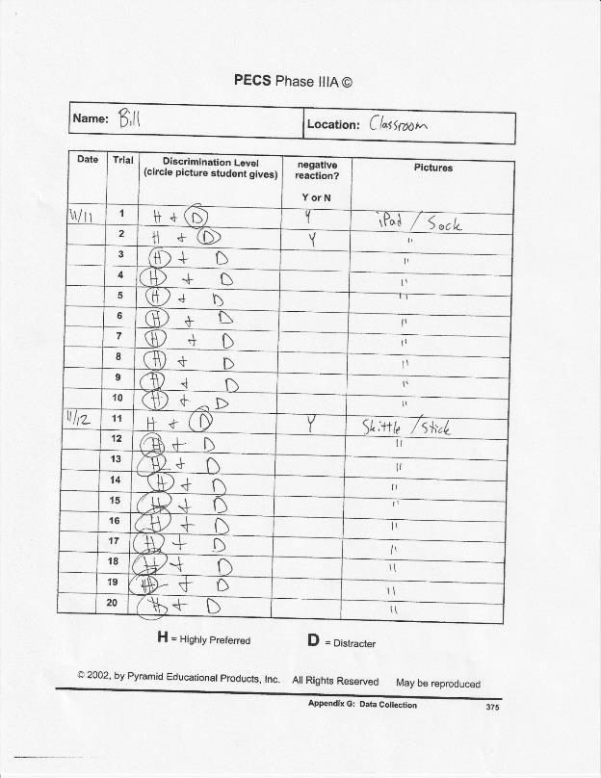

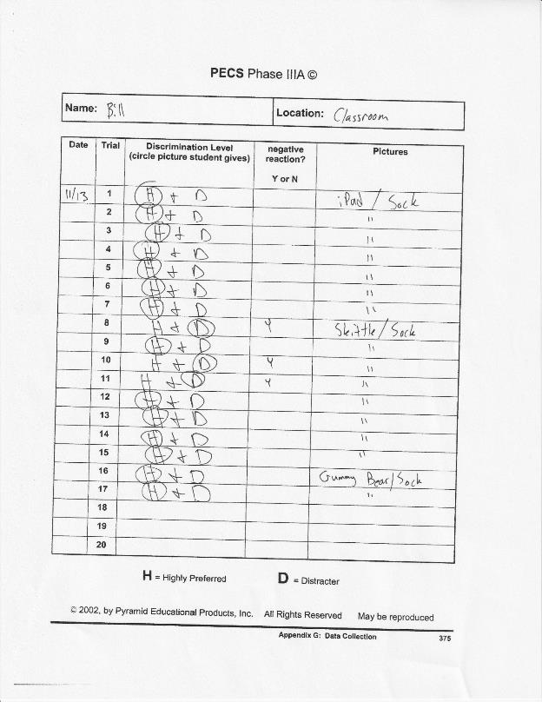

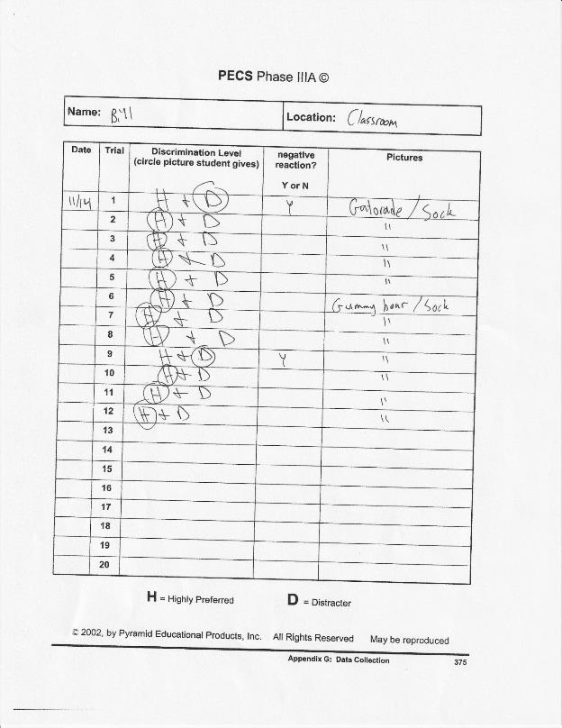

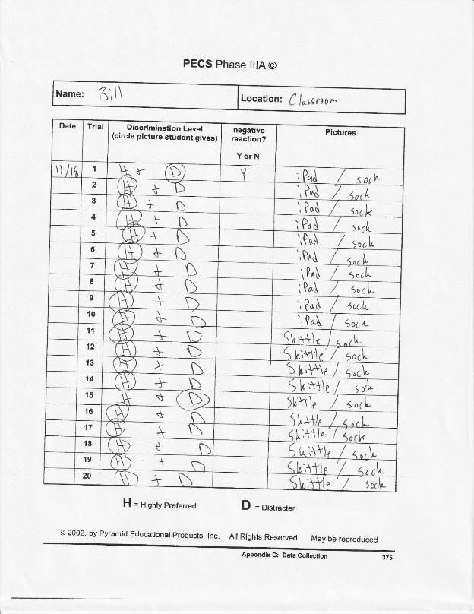

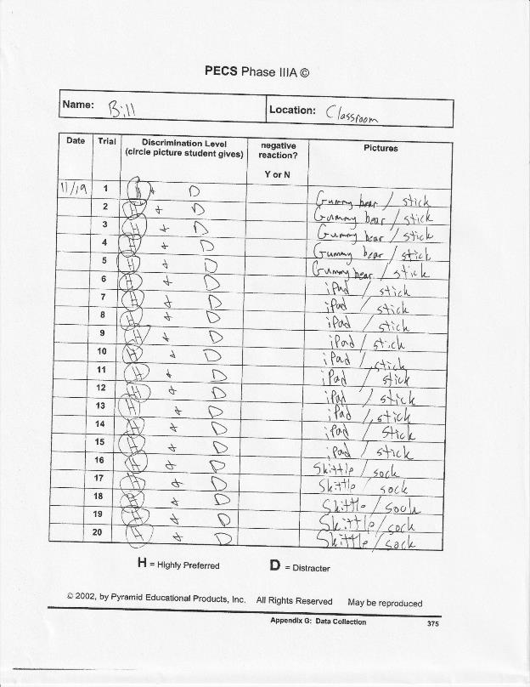

Appendix H

Bill’s Long-Term Graph

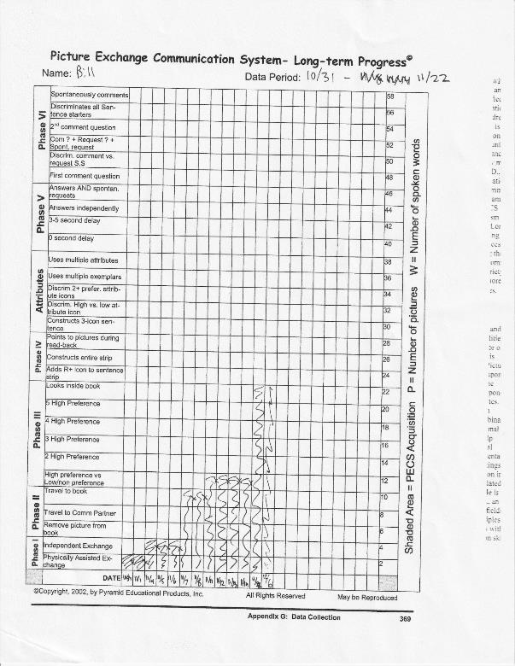

Appendix I

Phase IIIB Data Sheet

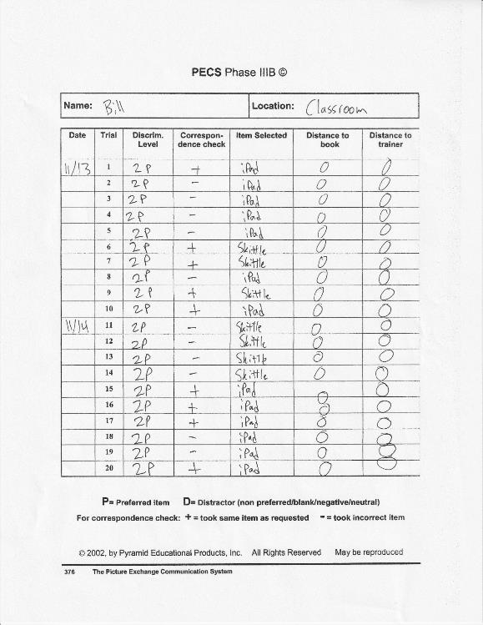

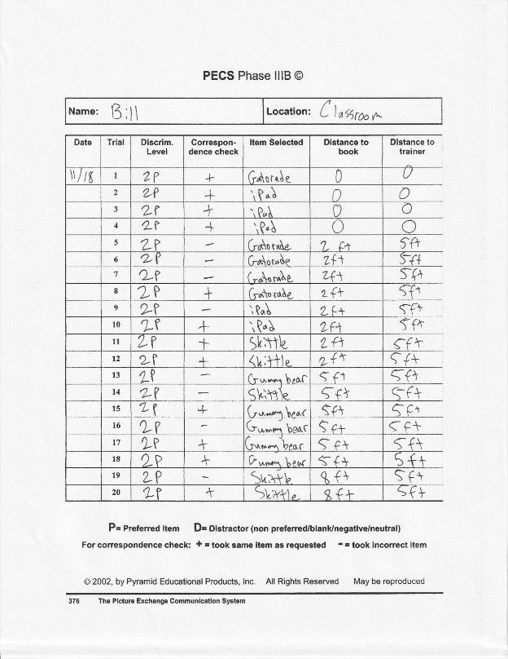

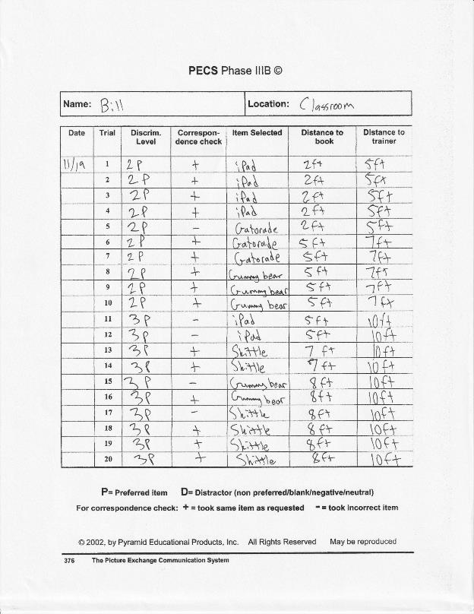

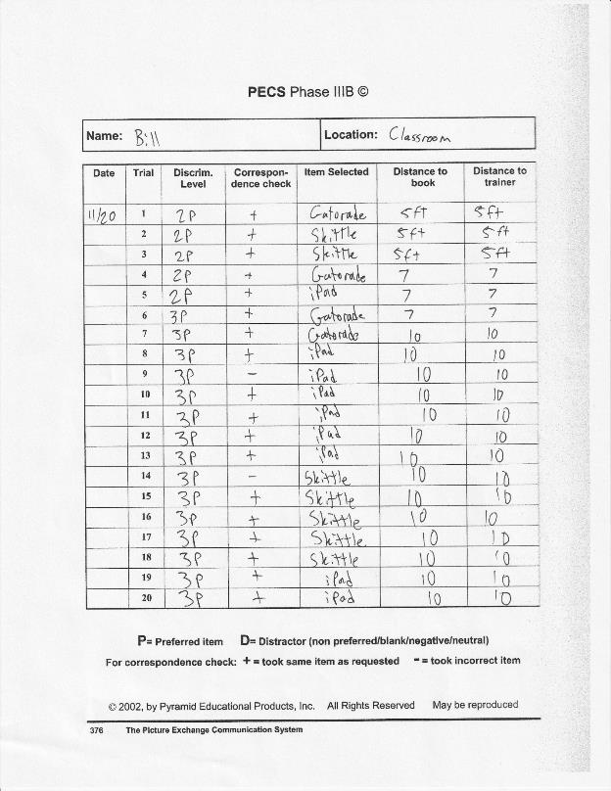

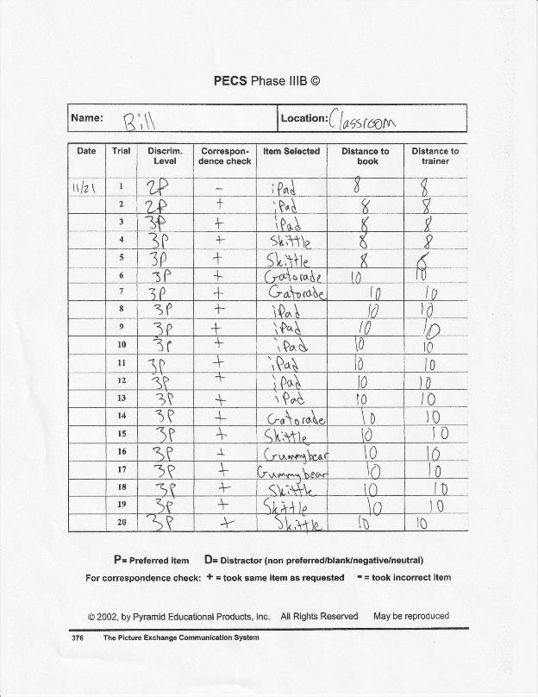

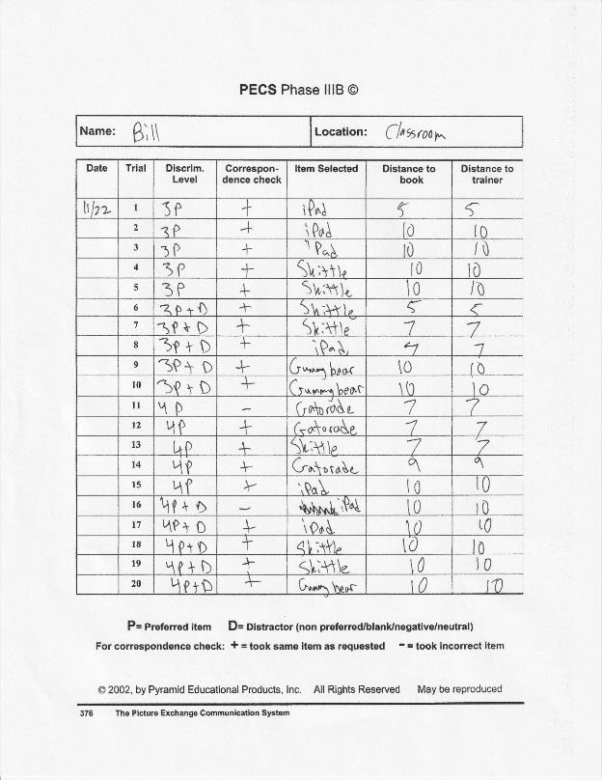

Appendix J

Phase IV Data Sheet

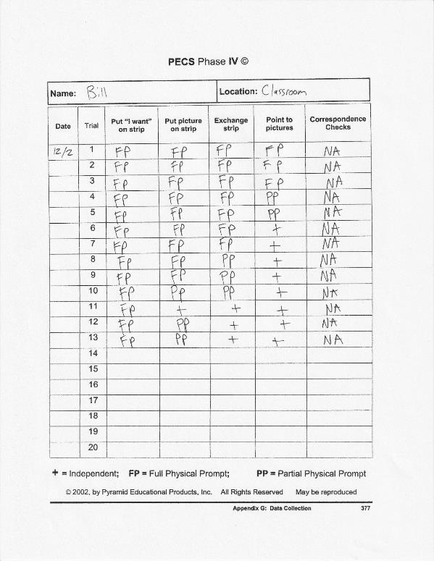

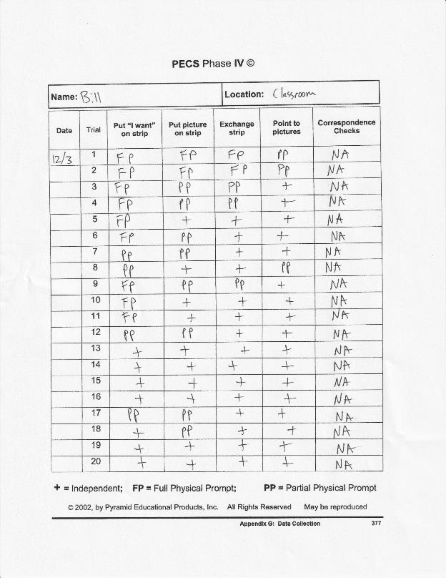

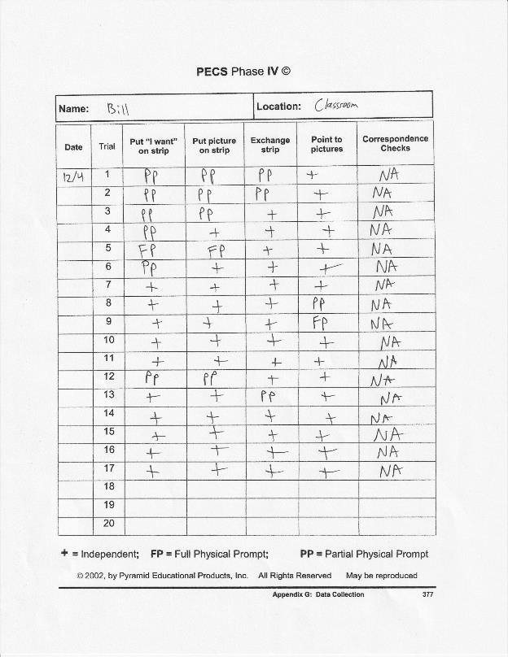

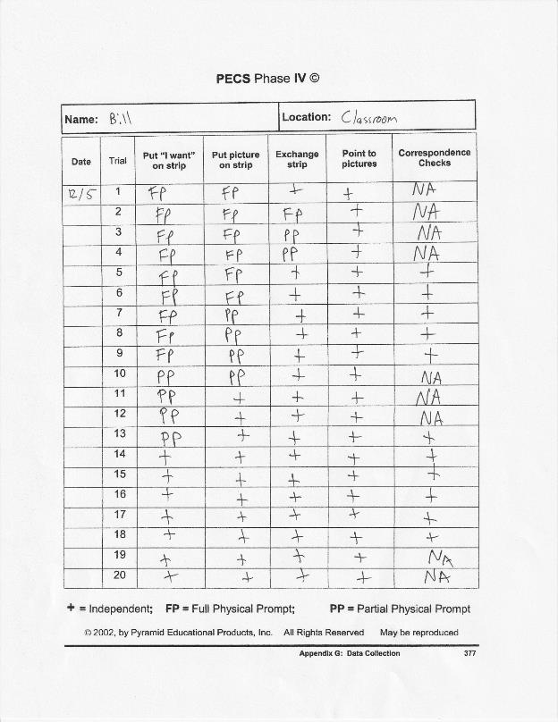

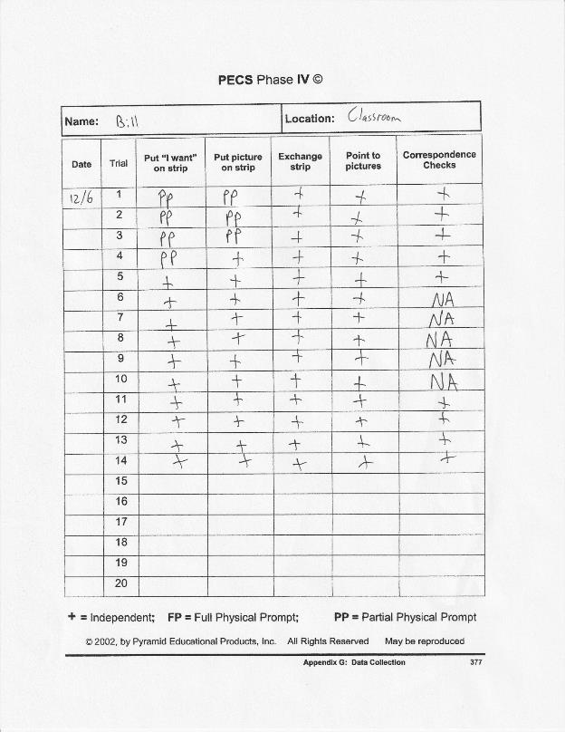

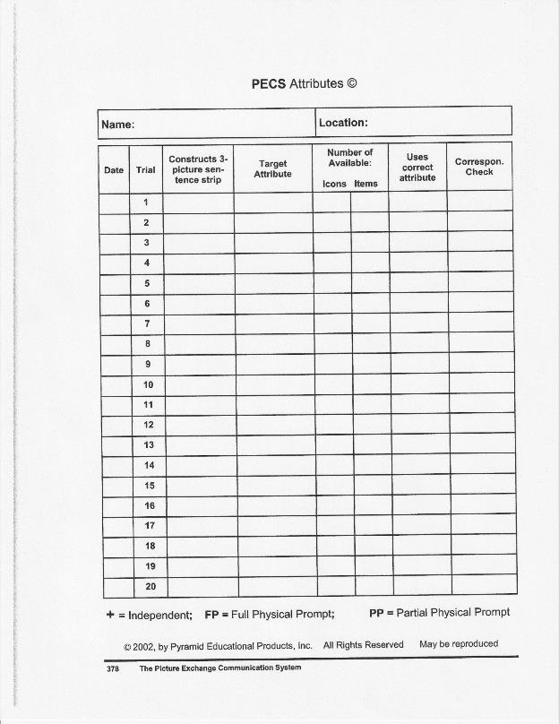

Appendix K

Phase V Data Sheet

