Zack Cartmel

SPED 785

M8: Psychological Report 2 Analysis & Interpretation

1. The assessments used in Nevah’s psychological report are:
   1. The Differential Ability Scales, Second Edition (DAS-II) is a cognitive assessment that assesses the general cognitive and processing abilities of a student.
   2. The Woodcock-Johnson Tests of Achievement, Fourth Edition (WJ-IV) is an academic achievement assessment that assesses the student’s reading, writing, and math abilities and allows for comparison with other students at the student’s grade level.
   3. The Review of Existing Data includes:
      1. A review of Neveah’s Social and Developmental History which looks at her family history.
      2. A review of her Academic History which looks at her history in special education, old assessment scores, and needs.
      3. A Behavioral Observation which describes her motivation and behavior during her assessments.
2. According to this psychological report, Nevah’s relative strengths are in her cognitive abilities. She performed highest on her cognitive assessment with a standard score of 87 on Nonverbal Reasoning which is a percentile score of 19, and a standard score of 79 on Spatial and Special Nonverbal Composite which is a percentile score of 8. These are not high scores compared to other students but compared to Nevah’s other skills they are areas of strength for her. These scores are all lower than expected for a student her age.

Standard scores are useful because it allows us to compare students’ scores because they are scored in a consistent way. Percentile scores tell us about the student’s performance in comparison to other students who took the test. The percentile score tells us what percent of other students who took the test the student scored better than or equal to.

Based on Nevah’s scores I think we can conclude that she has the ability to be performing better academically. Her cognitive skills are not a severe as her academic performance so I think that helps inform the team that she has the capacity to perform better academically.

1. According to the psychological report, Nevah’s biggest areas of need are Basic Reading Skills, Reading Fluency, and Written Language. These skills were assessed using the WJ-IV. All three of these areas scored a standard score of less than 40 which is a percentile score of 0.1 meaning that she scored worse than 99.9% of students on those parts of the assessment. These scores are all much lower than expected for a student her age.

Nevah is performing well below grade level in reading and writing. These areas definitely need to be addressed as she is clearly missing foundational skills to build on for her further academics. Her IEP goals should specifically target these areas in order to help her improve.

1. According to Nevah’s case study report, she enjoys playing on the iPad, music, Lego, and Carebears. These interests could be used as motivation to complete work. Nevah could be rewarded for working on reading, math, and writing by earning time on her iPad or time to play with Lego. In order to work on reading skills, the topics for reading could be related to her interests, like reading about music or about Carebears. She could also work on writing skills by writing about these topics, using her interests to motivate her.
2. Two evidence-based practices that could be used with Nevah are discrete trial teaching and reinforcement. Discrete trial teaching usually involves working one on one with the student and presenting instruction in distinct trials consisting of an instruction, a response, and a consequence. Reinforcement is a consequence following a behavior that increases the likelihood of that behavior occurring in the future. These two practices often go hand in hand. Nevah could be reinforced with an item of interest following a set number of discrete trial instructions. This would allow the teacher to specifically target needed skills in the DTT setting and motivate Nevah using interests and reinforcing correct responding.
3. A. Nevah struggles in all academic areas according to her WJ-IV assessment results. It is important that the team starts working on these deficits now so that they can bridge the gap rather than letting her fall further behind.

B. Nevah’s cognitive abilities out measure her academic performance. She shows that she should be able to perform better academically and the team should be encouraged by this and be motivated to help her improve her skill deficits.

1. A. According to the behavior observation, Nevah was focused while working, took her time, and did not display any issues. This is encouraging for working on new skills and is a good sign for participations outside of school and eventual transition planning.

B. Nevah’s deficits in reading could inhibit her interaction with her community. If she has trouble reading, it may lead to difficulties following instructions on food packages, reading a shopping list, or following written directions. This should be considered when working on this skill.

1. Based on the ASD Assessment Worksheet checklist in Appendix C, there are several categories missing information from them. There are no assessments for Sensory Status, ASD Assessment, Communication, Restricted and Repetitive Behavior, Sensory Processing, Motor Skills, Executive Function, Memory, and Attention, Emotional/Behavior Functioning, and Adaptive Behavior. Including assessments for these areas would be useful for giving a complete picture about Nevah.

The review of existing data includes some information about Nevah’s family system, academic achievement, developmental history, and a brief overview of a behavior observation that can give a small picture of Nevah’s behavior, but is not thorough.

The DAS-II conducted addresses Intellectual/Cognitive Functioning. This assessment was thoroughly completed and gives us a good idea of Nevah’s functioning. This assessment shows that this is an area of relative strength for Nevah.

The WJ-IV conducted addresses Academic Achievement. This assessment tells us about Nevah’s performance in reading, math, and writing. We can see from this assessment that these academic areas are areas of need for Nevah.

1. This psychological report only provides us with information related to Nevah’s Learning Characteristics. Based on the assessment, we can see that Nevah has deficits in this area. She shows good visual skills and a well-developed memory for detail and long-term recall as shown by the DAS-II, but has trouble with reading comprehension and executive function skills from the WJ-IV.
2. Goal 1: Nevah will increase sight word recognition by identifying at least 50 common sight words with 80% accuracy. Nevah struggles with basic reading skills. Increasing the number of sight words she recognizes will improve her reading skills since she struggled with this part of the WJ-IV assessment.

Goal 2: Given a picture and a set of 3 words, Nevah will match the correct word to the picture with 80% accuracy for 10 trials. Nevah struggles with reading comprehension. This will help her work on reading words and comprehending what they mean in the physical world.

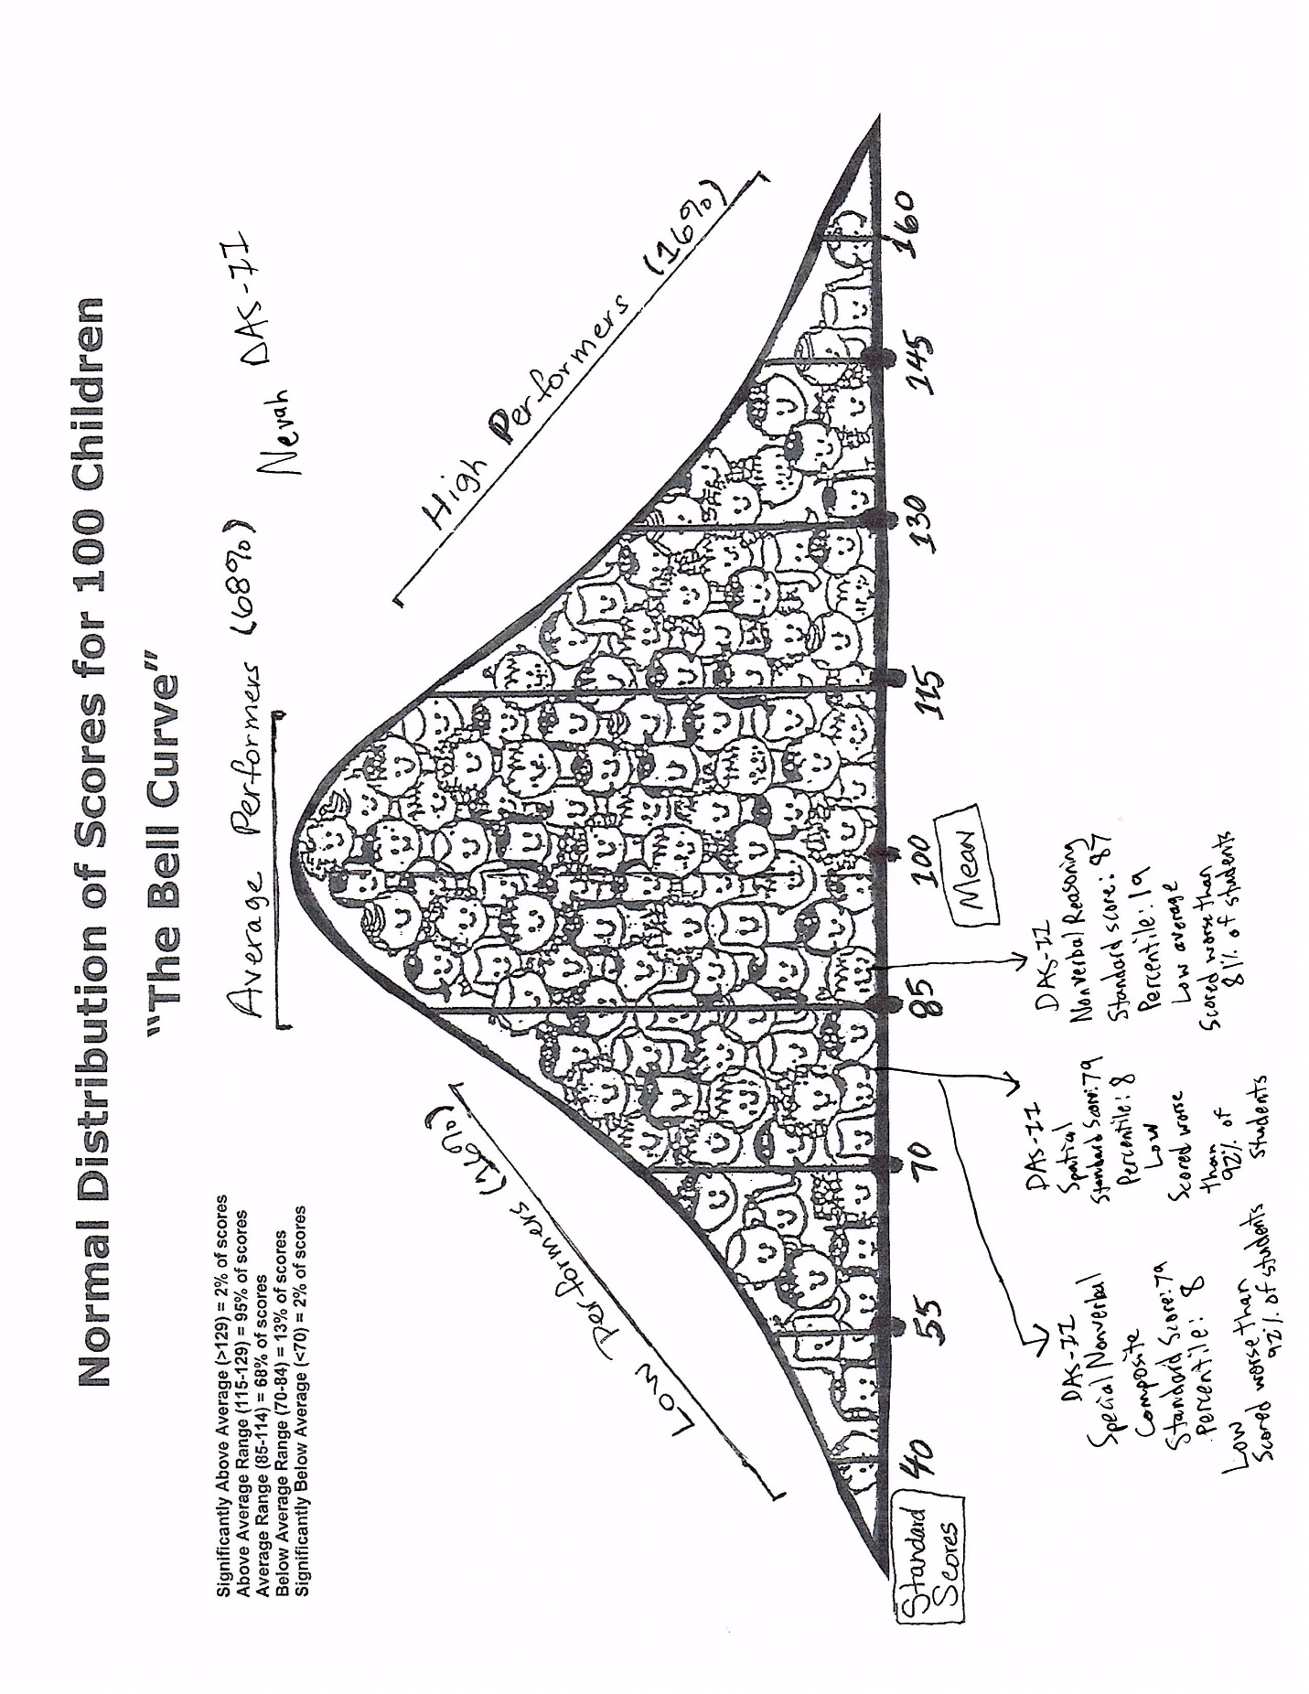

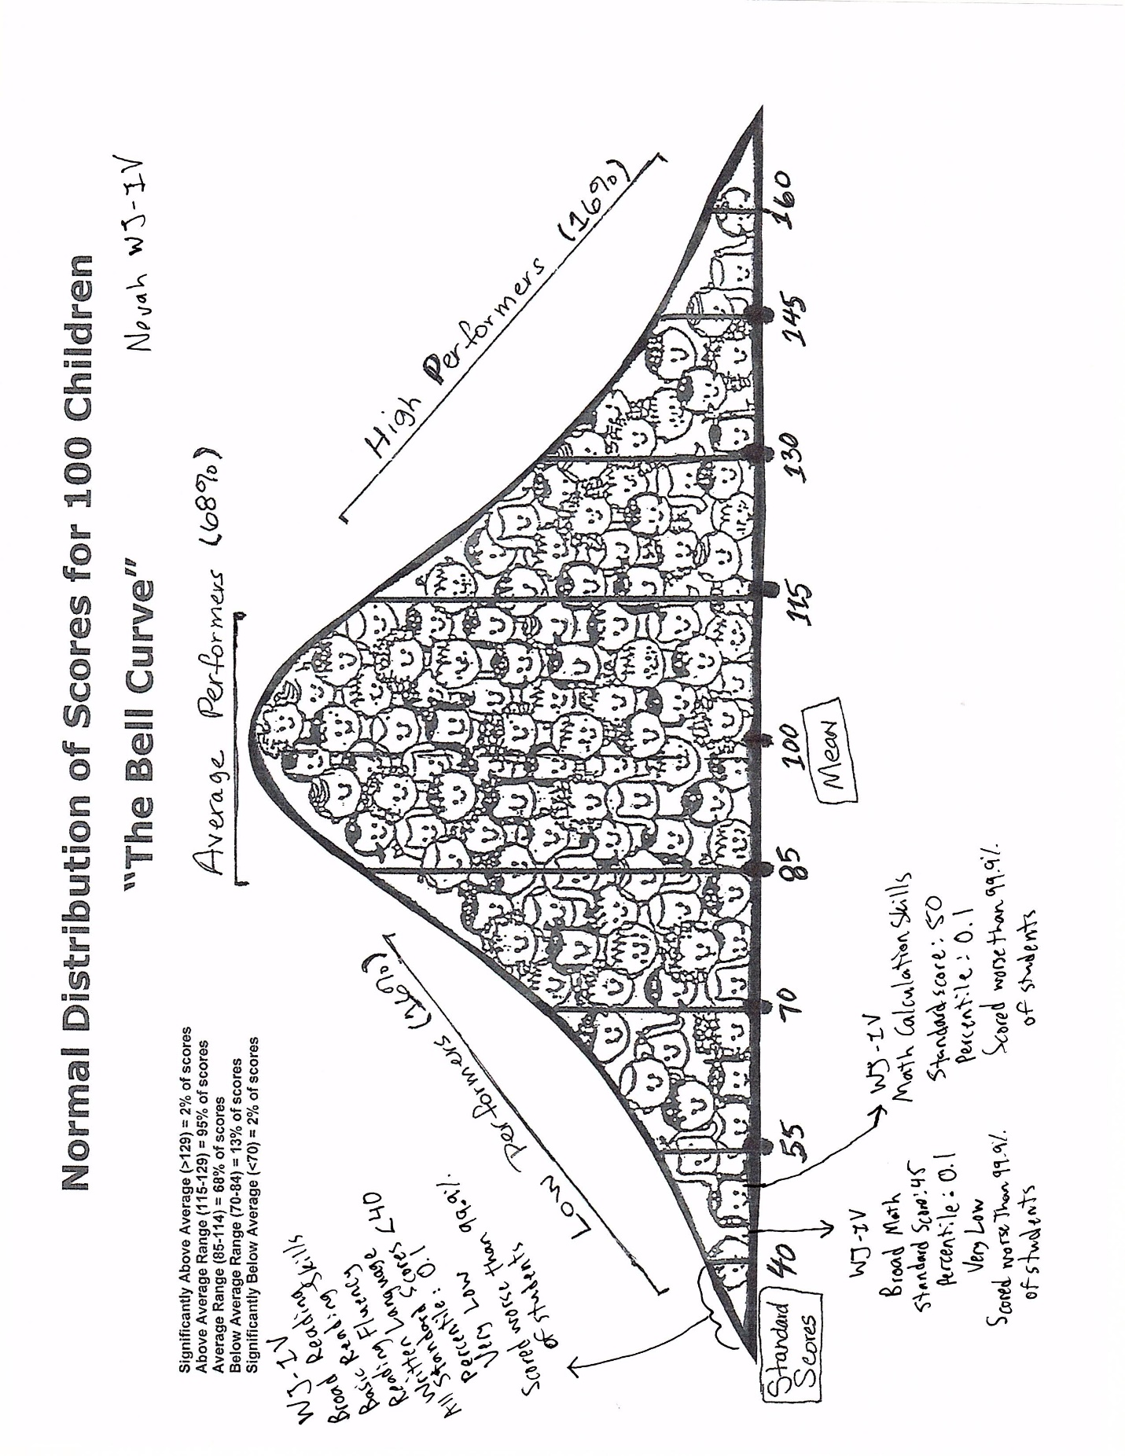

1. Once again, I thought this assignment was useful practice for reading a psychological report and understanding the results. It was good practice for explaining what the results mean in layperson terms and for recognizing the implications and explaining those implications to a family or IEP team.

It was also good to look at the psychological report in comparison to the indexes because it gave a good idea of what information the psychological report provided and what was missing. It was clear that this psychological report was meant to address academic concerns rather than overall functioning. The comparing helped me to recognize that.

References

Wong, C., Odom, S. L., Hume, K. A., Cox, A. W., Fettig, A., Kucharczyk, S., ... & Schultz, T. R. (2015).

Evidence-based practices for children, youth, and young adults with autism spectrum disorder: A

comprehensive review. *Journal of Autism and Developmental Disorders*, *45*(7), 1951-1966.

Wilkinson, L. A. (2017). *A best practice guide to assessment and intervention for autism*

*spectrum disorder in schools*. London: Jessica Kingsley.

University of Kansas, Special Education Department. (2018, October). Nevah Kelley Case

Study. Retrieved March 5, 2019, from https://kusped1.wixsite.com/nevah-casestudy