M1 Major Assignment: Structured Teaching

Zack Cartmel

SPED 860

**Description of Student**

Nevah is a 4th grade student who meets eligibility for autism support based on IDEA criteria. She enjoys music, playing outside, and building with Lego. She enjoys staying busy and working on tasks or engaging with toys. She has strong play skills and can be left to play independently for up to half an hour without any disruptions. Nevah is in a self-contained classroom for students with autism. There are three other students in her class with one teacher and one paraprofessional. Nevah remains on task when given work to do or given the instruction to choose a toy to play with. Nevah displays problem behavior when asked to transition between tasks. She will cry, scratch, or scream when instructed to clean up or when her time is up to work on a task. Currently, Nevah is not given any warning when it is time to change tasks. The teacher keeps track of the time and instructs students that their time with a toy is up or that they need to move on to the next task or activity. I hypothesize that the lack of support during transitions is impacting Nevah’s ability to transition appropriately.

I believe that a visual schedule and visual timer will help Nevah know what is coming next and how much time she has left with a particular activity. Sam and the AFIRM Team (2015) say that a student should be able to answer four questions at any point during their day. These questions are:

What should I be doing right now?

How much will I do/How long will an activity last?

How will I know when I am finished?

What do I do next?

A visual schedule and visual timer will help her be able to answer these questions by showing her what to do, what comes next, and how long each activity lasts for.

**Student Schedule**

Nevah spends most of her time in the self-contained classroom. This is where she works on academic, classroom, and vocational skills. She also transitions to an art classroom, to the gym for PE, and to the cafeteria for lunch. Here is Nevah’s schedule for the day:

* Arrival and breakfast – Nevah is dropped off by the bus and is picked up by the paraprofessional. She is brought to the cafeteria to get breakfast.
* Transition to classroom – Nevah and her classmates walk together from the cafeteria to the classroom where they put their backpacks in cubbies and put their take home folders in a tray on the teacher’s desk.
* Circle Time – Nevah and classmates participate in a group instruction time where they go over the months, days of the week, the day’s date, the weather, and read a story as a class.
* Lessons with Teacher – This is the 1:1 instructional time. The teacher will make use of a token board while working with Nevah to establish how much instructional time is left.
* Art – Nevah transitions with her peers to attend art with same aged general education peers with the support of the special education teacher and paraprofessional.
* Lunch
* Independent Work – Nevah will follow an activity binder with pictures of different independent tasks to know what activity she is working on and what activities she needs to do. When she reaches the back of the binder she will know she is finished and will see a picture of a preferred item as a reward for completing the binder.
* PE – Nevah and her classmates participate in a general education PE class with the support of their special education teacher and paraprofessional.
* Snack
* Independent Work - Nevah will follow an activity binder with pictures of different independent tasks to know what activity she is working on and what activities she needs to do. When she reaches the back of the binder she will know she is finished and will see a picture of a preferred item as a reward for completing the binder.
* Bus home

Within the self-contained classroom there are designated spaces for group instruction, 1:1 instruction, leisure or play time, and independent work.

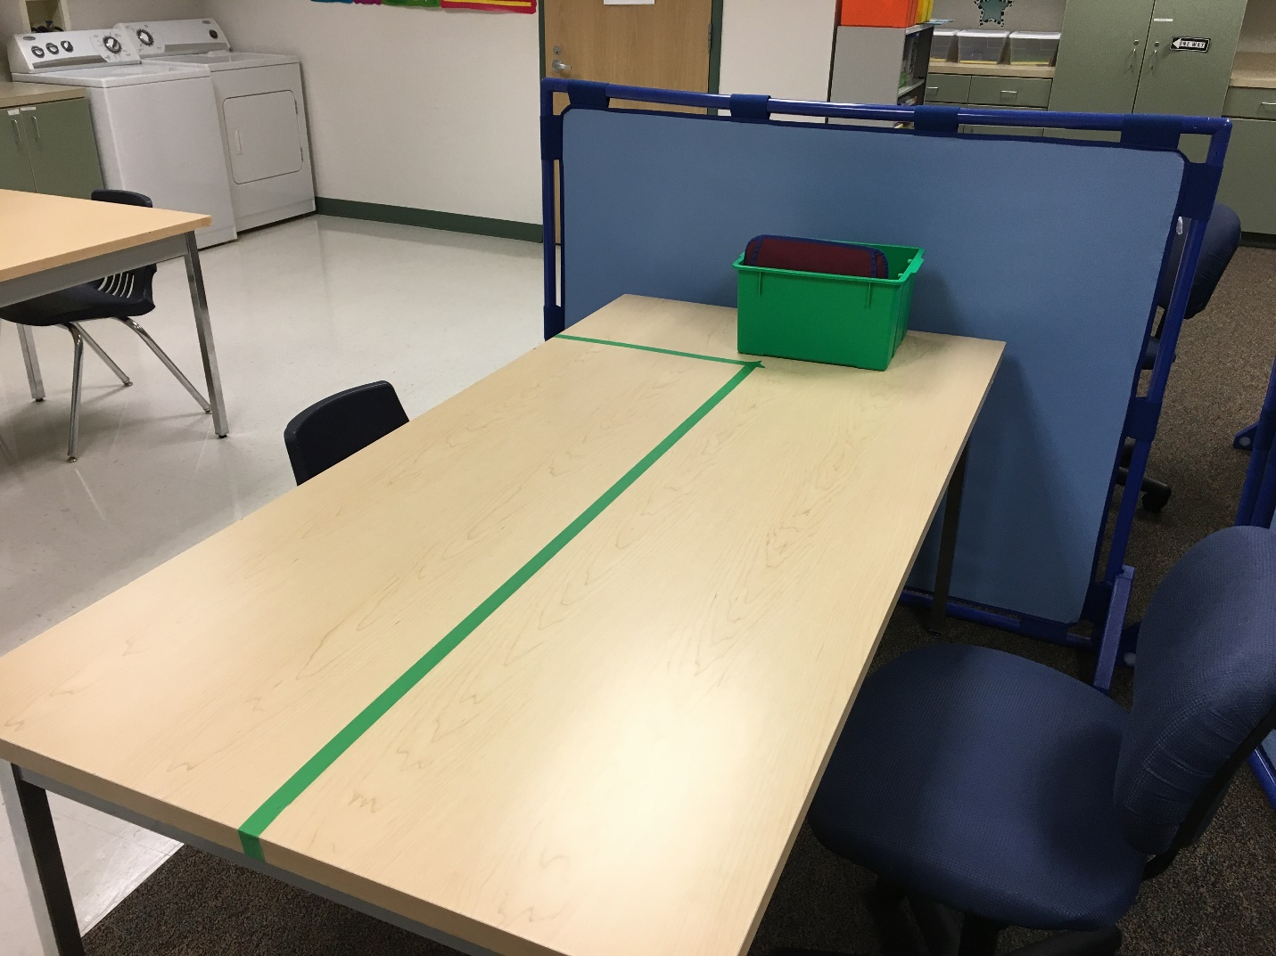Example of an independent work table:

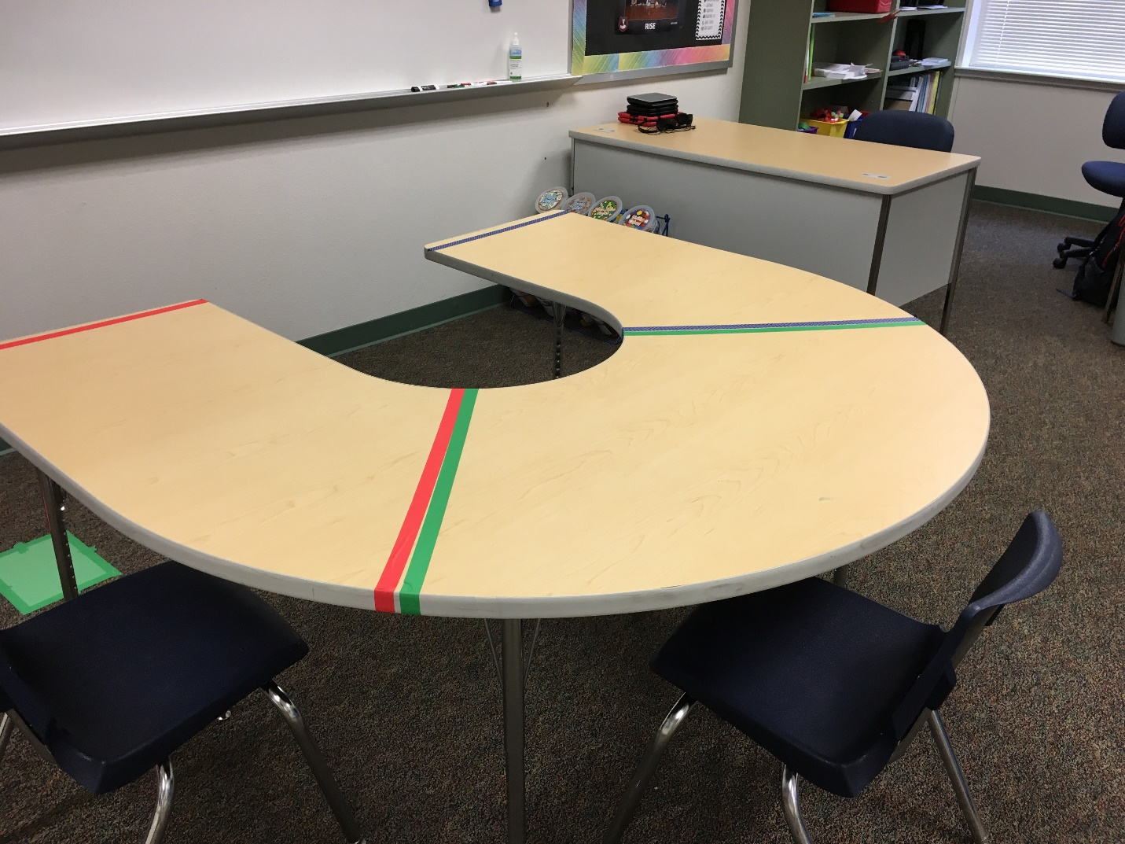Example of a group instruction table:

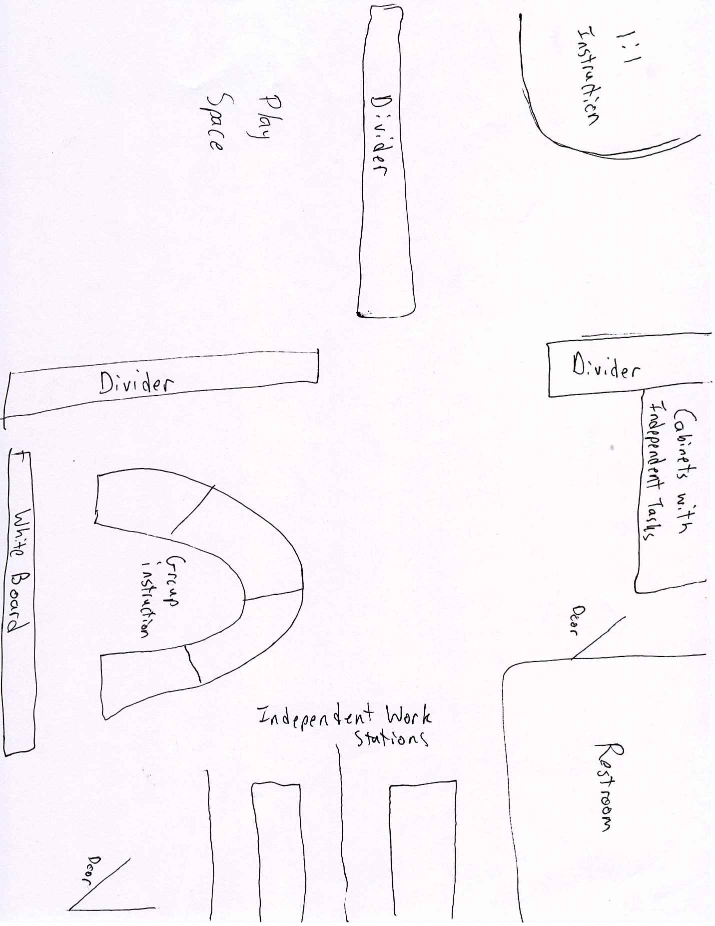Classroom layout example:

**Implementation and Assessment**

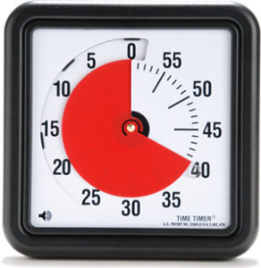

[This Photo](http://www.aulautista.com/2011/02/03/time-timer-o-como-medir-el-tiempo-visualmente/) by Unknown Author is licensed under [CC BY-SA-NC](https://creativecommons.org/licenses/by-nc-sa/3.0/)

The visual schedule will travel with Nevah and each activity will have an image matched to it so that Nevah knows what she is doing at the time. The next activity will also be on the schedule so Nevah knows what comes next. A visual timer will be used to show Nevah how much time is left and when it is time to transition to the next activity. When the timer goes off she will know to move on to the next thing on the schedule. In order to teach Nevah how to use the visual schedule, the teacher or paraprofessional will use physical prompting from behind the student to teach her how to navigate the schedule (Ganz, 2007). The prompts will be faded until Nevah is using the schedule independently.

In order to assess the effectiveness of the visual schedule and visual timer, the teacher will monitor Nevah’s behavior to see if occurrences of crying, scratching, or screaming during transitions decrease over time. If they do, we can conclude that the program has been effective in supporting Nevah during transitions and allowed her to do so more effectively.